5G MARKET Readiness in Mongolia

ITU
February 2022


Contents
1. Introduction 2
2. The Development of 5G/IMT-2020 3
2.1 Towards IMT-2020 3
2.2 5G Deployment 4
2.3 5G an Enabler of the Digital Economy 4
2.4 Opportunities for Mobile Operators 6
2.4.1 Fixed Wireless Access – Bridging the Digital Divide 6
2.4.2 Network Virtualisation & Cost Efficiency 7
2.4.3 Smart Cities and Industrial Transformation 8
3. Current Situation in Mongolia 10
3.1 Digital Nation 10
3.2 ICT Skills 12
3.3 Mobile Market Structure 13
3.4 Network Infrastructure 15
3.5 Broadband Services 16
3.6 5G Development in Other Markets 16
4 5G Readiness 18
4.1 End-User Readiness 19
4.2 Infrastructure Readiness 20
4.3 Industry Readiness 21
4.4 Regulatory Readiness 23
5 Gap Analysis 25
6 Summary and Recommendations 27
6.1 Accelerating the Development of 5G 27
6.2 The Regulator Can Take the Lead 28

Introduction

Mobile communications are now an integral part of people’s lives. Through mobile devices, people are able to remain constantly connected and gain convenience via a wide range of applications. The mobile technology continues to evolve and it is expected to have a greater impact on society and economy. It is foreseen that new demands, such as more network capacity, many more devices with diverse service requirements, better quality of user experience (QoE) and better affordability, will require an increasing number of innovative solutions.
The ITU has worked with the industry to define the framework and overall objectives of the IMT-2020 (5G); and guide the standardization process. The deployment of 5G is underway in many countries around the globe and 5G-capable devices are now widely available, supported by major vendors. Besides offering faster speeds than 4G/LTE, 5G enables new capabilities including enhanced reliability, ultra-low latency and the ability to connect much higher number of IoT devices. This opens up new opportunities for 5G to support industry use cases, going beyond the connectivity for consumer devices.
This being the case, regulators and operators are working closely to accelerate the implementation of 5G. Besides providing spectrum for 5G networks, there is also a need to ensure that the overall 5G ecosystem is developed and ready to support new applications and services. In Mongolia, the Ministry of Digital Development and Communications (formerly Communications and Information Technology Authority or CITA) and the Communications Regulatory Commission (CRC) are also keen to drive the development of 5G. The government can play a key role by developing the necessary policies to facilitate the deployment of innovative services as well as to review existing regulatory frameworks to ensure that they continue to be relevant in the 5G era.
The purpose of this study is to assess the readiness of Mongolia to support the implementation of future IMT (5G) networks. The assessment is based on international benchmarks and gathering inputs from discussion with relevant stakeholders in Mongolia. This report highlights the development of 5G/IMT-2020 globally and the opportunities it presents. The market readiness as well as the regulatory challenges are also discussed in this report.

The Development of 5G/IMT-2020

2.1 Towards IMT-2020
The ITU has been coordinating efforts of government, industry and private sector in the development of a global broadband multimedia international mobile telecommunications (IMT) system. In the early 2000, the ITU started the standardization of IMT-2000 which is marketed as 3G commercially. The early 2010s saw the implementation of IMT-Advanced (4G) and in early 2012, ITU Radiocommunication sector (ITU-R) embarked on a programme to develop “IMT for 2020 and beyond”, setting the stage for 5G research activities.
Mobile devices play various, continuously evolving roles in everyday life. The development of 5G is envisaged to support a new wave of applications beyond the current mobile broadband applications for consumers. 5G is designed to overcome some of the current challenges in supporting a plethora of applications. Broadly speaking, 5G can enable the following three usage scenarios:
Enhanced Mobile Broadband (eMBB): Mobile Broadband addresses the human-centric use cases for access to multi-media content, services and data. The demand for mobile broadband will continue to increase, leading to enhanced Mobile Broadband. This usage scenario covers a range of cases, including wide-area coverage and hotspot, which have different requirements. For the hotspot case, i.e., for an area with high user density, very high traffic capacity is needed, while the requirement for mobility is low and user data rate is higher than that of wide area coverage. For the wide area coverage case, seamless coverage and medium to high mobility are desired, with much improved user data rate compared to existing data rates.
Ultra-reliable and low latency communications: This use case has stringent requirements for capabilities such as throughput, latency and availability. Some examples include wireless control of industrial manufacturing or production processes, remote medical surgery, distribution automation in a smart grid, transportation safety, etc.
Massive machine type communications: This use case is characterized by a very large number of connected devices typically transmitting a relatively low volume of non-delay-sensitive data. Devices are required to be low cost, and have a very long battery life.
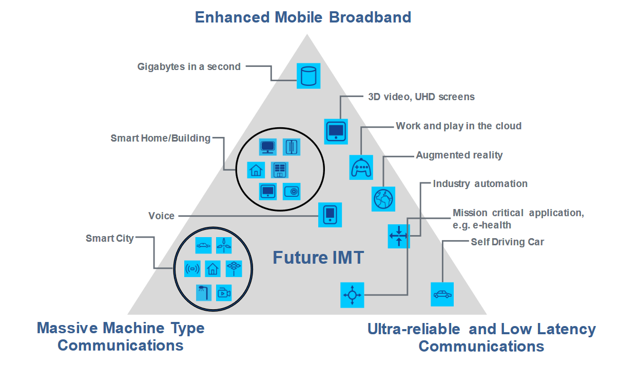
Figure 1: Usage Scenarios for IMT in 2020 and beyond

5G Deployment
The deployment of 5G is gaining pace and commercial 5G is already available around the world. According to the Global mobile Suppliers Association (GSA), by December 2021, 481 operators in 144 countries/territories were investing in 5G; while a total of 189 operators in 74 countries/territories had launched one or more 5G services. Ericsson estimates that 5G networks will cover over 2 billion people by the end of 2021. The equipment vendor expects the coverage will extend to about 75 percent of the world’s population by 2027. Another forecast by GSMA points to 5G accounting for as many as 1.2 billion connections by 2025.
This network rollout is supported by the device ecosystem. According to GSA, the count of announced 5G devices exceeded 1,200 in December 2021; with potentially over 1,000 5G devices becoming commercially available by the first quarter of 2022. It is worth noting that the range of devices is not limited to phones but includes various other devices that can support different use cases – e.g., fixed wireless access (FWA), industrial applications, and mobile workforce.
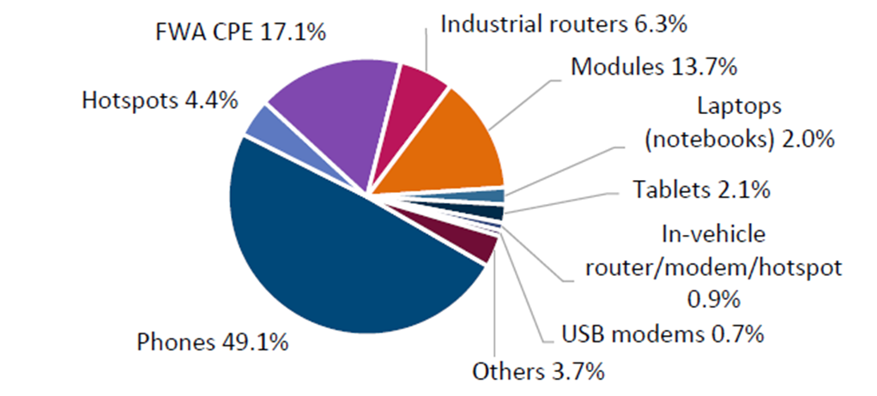
Figure 2: 5G User Devices by Form Factor, Dec 2021 (Source: GSA)
The momentum for 5G is strong, backed by major operators and equipment manufacturers. However, the development of applications and services that tapped into 5G’s unique characteristics (e.g., ultra-low latency, network slicing) is still nascent. Nevertheless, there are immediate opportunities in delivering higher quality FWA services. For some operators, 5G has also allowed them to speed up the migration of customers from legacy systems (e.g., 2G and 3G) to 4G and 5G services. This enables better cost efficiency and the opportunity to offer enhanced mobile data services.

5G an Enabler of the Digital Economy
Connectivity, data, AI, automation, and other digital technologies are enabling various industries to transform their businesses. The hyper connectedness of people, businesses and things through technologies such as mobile, IoT and the Internet provide the opportunity for countries to create a digital economy. Governments have developed digital economy strategies that include the enhancement of infrastructure; the development of digital skills, driving adoption including among small and medium-sized businesses (SMBs), implementing digital government services, and ensuring cybersecurity and safety. In this regard, 5G will be a key enabler of the digital economy.
Various studies have been conducted to quantify the economic benefits of 5G. For example, PwC estimates that 5G will have an economic impact of US$1.3 trillion by 2030 globally. This is based on economic modelling that looks at use cases across key industries including healthcare, smart utilities, consumer and media, industrial manufacturing, and financial services; which PwC believes stand to benefit significantly from 5G. In the case of Mongolia, 5G can also help to transform mining operations.
  Mining | Mobile technology has started to transform mining operations, as more mine sites are setting up private mobile networks to enable automation (e.g., asset monitoring and autonomous haulage). With higher bandwidth, lower latency, and the ability to connect more devices, 5G enables new opportunities to further enhance the efficiency and safety of mining operations. For example, Codelco in Chile is testing the use of 5G to carry high-definition, real-time video for remote monitoring and decision-making in the capital city, Santiago, 1,500 kilometres away from the mine site. With sensors in assets used at the mines, predictive analytics and preventive maintenance can improve productivity dramatically. The ability to detect collision, safety non-compliance, and environmental factors can improve safety of workers at the site.
 | Telemedicine has become a reality amid the pandemic and 5G helps to deliver remote health services including remote surgery. In China, a doctor in the city of Sanya inserted a stimulation device in the brain of a Parkinson’s patient 1,900 miles away in Beijing. There are ways 5G can help to improve productivity within health care facilities. For example, Siriraj Hospital in Thailand has trialled unmanned vehicle to offer contactless delivery of medical supplies. Other possibilities include using drones for delivery of medicines and blood samples, and automated drug dispensing systems.
 | As consumers and power generators adopt renewable energy, there is an opportunity to leverage 5G for enabling a distributed energy system. Consumers with solar panels can offer to share their excess with the grid or among households. With 5G-enabled meters and probes with high reliability and low latency, an energy management system can be in place to manage the of energy sources between the grid and homes. The system can also predict energy demand and detect outages. Moreover, while 5G is a more energy-efficient technology, it is expected to consume more energy due to the number of sites and higher data transmission. Huawei’s 5G Power for example uses intelligent technologies like peak shaving, voltage boosting, and energy storage to enable 5G sites to be deployed without the need to change the grid and power distribution. Besides energy grid, 5G can in the same manner improve water management and waste management through real-time data that can help to prevent wastage and improve efficiency.
 | The move to Industry 4.0 and smart factory is underway. The use of robotics, automation, IoT, AI, AR/VR and 5G are transforming manufacturing processes, enabling greater efficiency and improving work safety. While a smart factory is being powered by real-time data, it is crucial for the connectivity to various devices to be reliable, security and with ultra-low latency. Car manufacturers have been among the early adopters of 5G and some plants have deployed 5G private networks to achieve the desired performance. For example, Ford uses a mobile private network for its electric vehicle plant in the UK to analyse and control laser welding machines. AR for troubleshooting, workforce safety insights, defects detection and preventive maintenance are some of many potential use cases.
 | The retail sector has seen a considerable impact due to the pandemic and companies have been embracing digital solutions to move their businesses online. At the same time, retailers are also looking at ways to optimise their stores and create new digital experiences. Operators such as Singtel for example has started to deploy indoor 5G at major shopping malls in Singapore, partly to enable retailers to transform their outlets. Some potential use cases include real-time inventory management, theft detection, digital signages, and real-time store activity for contextual and targeted promotions.
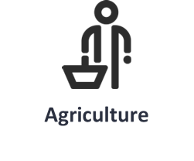 | Even in agriculture, 5G and IoT solutions can help to improve yield and farmer productivity through precision agriculture and smart farming. In the Philippines, the Cauayan city looks to transform itself from an agricultural town to a smart city through setting up 5G network and rolling out a Digital Farmers Programme. In the UK, 5G Rural First launched a mobile app to allow farmers to track cows to receive real-time information about their health and behaviour. Other potential areas include remote water and energy monitoring, real-time weather information, soil measurements, vehicle tracking, etc.
Figure 3: 5G Industry-Specific Use Cases

2.4 Opportunities for Mobile Operators
Mobile operators are looking at different angles to justify the business case to roll out 5G. There are immediate opportunities as well as long-term strategic advantages. While there are hurdles in 5G implementation (e.g., the availability of spectrum), finding the business case is just as fundamental. The business case varies depending on each operator’s existing infrastructure, services and customer base.

2.4.1 Fixed Wireless Access – Bridging the Digital Divide
With faster speeds IMT will continue to help bridge the digital divide. The ability to deliver high-speed and reliable Internet, has motivated many operators to offer 5G FWA. This opens up new revenue streams for mobile-only operators; or complements existing fixed broadband services for converged operators where fixed lines are not available. Some operators find offering 5G FWA to homes more cost effective and faster than laying fibre optic cables; while delivering comparable speeds. For example, Telia in Norway and Telenor in Finland are replacing DSL service with 5G FWA.
Other operators also see the potential to support rural communities with 5G especially in areas where fixed lines are not available. By using low-band spectrum (e.g., 700MHz), it can become commercially more attractive to deliver high-speed broadband to sparsely populated rural communities. This is crucial for supporting remote learning, telemedicine, and smart farming for people living in the rural areas. For example, T-Mobile in the US has been driving 5G deployment in the rural areas and is registering download speed of 53.4 Mbps. In December 2021, GSA catalogued 81 operators that were marketing residential or business 5G FWA broadband services, up from 44 a year ago (84% growth). GSA observed that these services were offering speeds ranging from 50 Mbps to 4.2Gbps downlink.

2.4.2 Network Virtualisation & Cost Efficiency
The demand for mobile data traffic has been growing rapidly; a consistent trend around the globe. This is especially apparent during the pandemic as people rely on the Internet and mobile devices for information, communications (more video conferencing), shopping, entertainment, etc. Mobile operators are constantly upgrading their networks to deliver the necessary capacity and speeds to maintain user experience. Some operators (e.g., Telstra) believe that 5G is more cost-effective in supporting the growth of mobile data traffic. This is based on the enhanced spectral efficiency of 5G through modulation, coding and massive MIMO; as well as carrier aggregation.
Just as LTE saw enhancements through LTE-Advanced, 5G will see new capabilities and functions through 5G-Advanced. This is expected to be part of the work undertaken by 3GPP in 2022 in its Release 18 standardisation. The industry is looking at various possibilities including greater energy efficiency, higher accuracy in positioning, enhanced coverage through reduced capability for user equipment, and more artificial intelligence (AI) / machine learning (ML) capabilities. While the technology will not be available in the next few years, there is a level of certainty that a roadmap for enhancements will continue as has been during the development of 3G and 4G.
More significantly, mobile operators around the world are transforming their networks from RAN to core as they look for a more cost-effective approach to implement 5G and maintain their mobile networks going forward. For example, virtual RAN and Open RAN removes the need for proprietary hardware and improves flexibility. There is also work in progress for 5G core to be hosted in public clouds. Microsoft’s acquisition of Affirmed Networks has facilitated the development of Azure for Operators which combines cloud, cellular, and edge computing capabilities. The company announced in June 2021 that AT&T would be moving its 5G mobile network to Azure for Operators to increase productivity and cost efficiency. Nokia and Google Cloud also announced a partnership in March 2021 to develop cloud-based 5G radio solutions.
Directionally, mobile operators are pushing for greater efficiency and a less capital-intensive operating model. This has motivated operators to share infrastructure for cost optimisation especially in 5G implementing. In some cases, this is also a result of a lack of new 5G spectrum for all mobile operators. While operators have been sharing passive infrastructure for some years, it is becoming more common for active infrastructure sharing for 5G implementation. This is enabled by the development of multi-operator core network (MOCN) and multi-operator radio access network (MORAN). MORAN allows the sharing of the radio access network (RAN) while each operator uses its own dedicated spectrum. MOCN allows both RAN and spectrum to be shared while each operator continues to maintain its own core network. Sharing of active infrastructure means lowering of equipment costs as well as ongoing operational costs (e.g., manpower, hardware maintenance, and lower energy consumption).
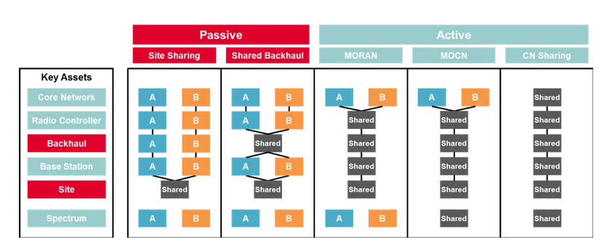
Figure 4: Infrastructure Sharing (source: GSMA)

2.4.3 Smart Cities and Industrial Transformation
With mobile subscription reaching saturation in many markets, connecting machines is creating new revenue opportunities for mobile operators. The benefits go beyond the consumers (e.g., wearables and connected homes). Industrial IoT is creating values for businesses in terms of process automation, productivity improvement and cost reduction. Deployed in the context of a smart city, it can help governments achieve better urban planning and environmental sustainability. There are various use cases today addressing areas such as utility (water and energy management), transportation (intelligent transport systems), smart buildings, and healthcare (telemedicine).
There are existing technologies supporting IoT solutions, from traditional M2M to LTE-M, NB-IoT, LoRa and SigFox. Narrowband technologies such as NB-IoT, LoRa and SigFox is suitable for connections that require infrequent and low data rate transmission. These narrowband devices (e.g., smart energy meters) can operate for 10 years without the need to change the battery, which saves manpower from frequently replacing batteries of thousands of devices. For non-static IoT solutions and higher data rates, LTE-M is a better fit. While 5G IoT capability is still being developed, it will greatly enhance the connectivity of sensors and IoT devices to increase the number of use cases for business and social applications. 5G provides the ability to connect a higher density of devices (1 million device connections / km²), improved reliability (10⁻⁹ error-rate), low latency (1ms) and higher energy efficiency. For example, lower latency is required for time sensitive applications such as autonomous vehicles, industrial automation and online gaming. Reliability is crucial of mission-critical applications such as those in healthcare and security.
Multi-access edge computing (MEC) is another area being developed that will bring about important changes to enable new real-time, mission-critical use cases. While cloud computing has brought about cost-effective digital solutions (e.g., data analytics, AI/ML, video), it is not feasible to support real-time, mission-critical solutions (e.g., computer vision for detect detection at an assembly line) due to the network latency and bandwidth required. There is also data privacy and security considerations for highly regulated industries (e.g., healthcare and banking). 5G connectivity plus MEC (bringing the cloud capabilities to the network edge) significantly reduces the network latency and performance of real-time applications; and provides an additional layer of security protection. Hyperscalers including AWS, Microsoft and Google Cloud have been working with mobile operators to develop MEC solutions, bring cloud solutions to the mobile edge. AWS for example, has already set up MEC zones (known as Wavelength Zones) in the US, Japan, Korea and the UK in partnership with Verizon, KDDI, SK Telecom and Vodafone respectively.
Private 5G networks is another possibility for enterprises that require extensive connectivity for secure, real-time applications. Some mining companies, manufacturing plants, ports and airports have already deployed private wireless networks to automate operations. Private 5G is also an option in areas where the hyperscalers and mobile operators have not set up an edge location. For example, Telefonica Tech signed a collaborative agreement with Microsoft in May 2021 to integrate private 5G with Azure Private Edge Zone to enable automation and control of industrial processes.
Network Slicing will be a key 5G capability as the technology becomes mature, and operators implement the 5G standalone architecture (SA). Through a 5G SA cloud native service platforms, network slices can be provisioned with different quality of service and latency to meet specific customer needs around applications, service levels and devices. Network slicing allows mobile operators to offer “slices” of their networks to different enterprises for their exclusive use, based on their required service levels. For example, an operator can set up a network slice to support autonomous vehicles that require low latency and ultra-reliable but not necessarily high data rates; and configure another network slice for video-streaming that requires high data rates and low latency.

Current Situation in Mongolia

3.1 Digital Nation
In 2020, the Mongolian government set out its five-year mission to build a ‘digital nation’. The overarching goal is to harness digital technologies to facilitate innovation, streamline public services, and diversify the county’s mining-reliant economy. Under the Digital Nation initiative, there are six key goals as shown in Figure 5.
Figure 5: Six Goals to Become a Digital Nation
In early 2021, E-Mongolia, an online platform for government services was launched. The platform provides more than 180 most in-demand services from the application of an ID card to the application for a business licence. The platform has significantly reduced the time for transactions across various government services, resulting in improvement in productivity and reduction in costs (e.g., paperwork, postage, travel costs, etc.). E-Mongolia has been a success, with more than 700,000 people using the platform, five months after the launch.
Digital infrastructure is a key pillar underpinning the other digital goals. The telecommunications infrastructure is critical to support the economic development, particularly in driving the digital economy. Globally, the adoption of digital services is rapidly rising resulting in more economic activity online connecting people, businesses, devices and processes. The backbone of digital economy is hyper-connectivity and the mobile network infrastructure plays a crucial role in connecting a growing number devices and machines.
In Mongolia, the Digital Nation program seeks to connect people and businesses through digital skills development, digitisation of public services, and innovative solutions across different industries. The expected outcomes for the Digital Infrastructure include:
- The completion of the network connection in rural areas
- Connecting most important tourism areas with reliable network
- Establishing Internet network along class A international roads
- Introduction of 5G in Ulaanbaatar
- Establishing national satellite ground station; and commencing the satellite launch preparation
The other five Digital Nation goals are also crucial in developing the digital economy. E-Governance will see the digitisation of government services and encourage citizens to go online instead of visiting government offices. Besides improving productivity, it also drives the usage of the Internet. As more services (both government and commercial) become available online, it is crucial to ensure information security and communications infrastructure is protected. This is vital especially when other critical infrastructure (e.g., transportation and utilities) become more connected; and more sensitive personal information (e.g., health records) become accessible online. Only when there are adequate cybersecurity measures, will people and businesses have the confidence to rely on the digital infrastructure for various services.
The Digital Nation program also highlights key industries that are crucial for the Mongolian economy. and programs to support start-ups, entrepreneurship and collaboration with international organisations are also key to facilitate innovation. As discussed in Section 2.3, 5G will play a part in industrial transformation. This will need a combination of the 5G infrastructure and new applications and services developed to meet the needs of the Mongolian industries. However, there is currently a lack of awareness among enterprises in these industries, with regard to 5G and solutions that it can enable to transform business operations.
Figure 6: Key Industries in Mongolia

Modernizing the Mongolian economy and digitising services will ultimately boost the competitiveness of Mongolia on the global stage. Based on the World Economic Forum’s Global Competitiveness Index for 2019, Mongolia was ranked 102 globally as shown in Figure 7. The digital infrastructure, ICT adoption, skills and innovation are key measurements of a country’s competitiveness. Mongolia will be able to improve its global ranking through effective execution of the Digital Nation program.
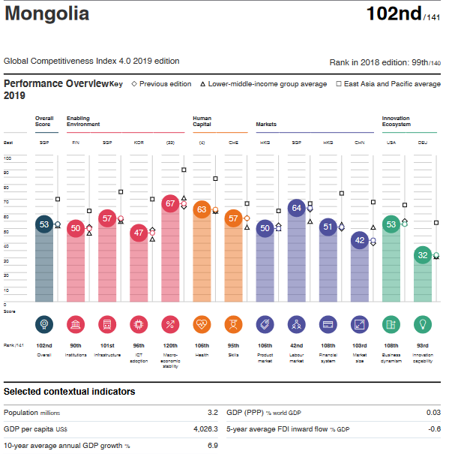
Figure 7: Mongolia’s Performance in the Global Competitiveness Index 4.0 2019 edition (Source World Economic Forum)

3.2 ICT Skills
Another key element of the Digital Nation program is digital literacy. A digital economy needs to be underpinned by a population with various digital skills ranging from the ability to perform basic tasks such as data entry and word processing; to advanced skills in areas such as application development, cybersecurity, data science and analytics. Based on ICT’s Digital Development Dashboard, Mongolia still has some catching up to do in ICT skills development compared with some of the leading countries in digital skills such as Estonia, Saudi Arabia, Singapore and South Korea. The establishment of an E-Mongolia academy will help to nurture talent.
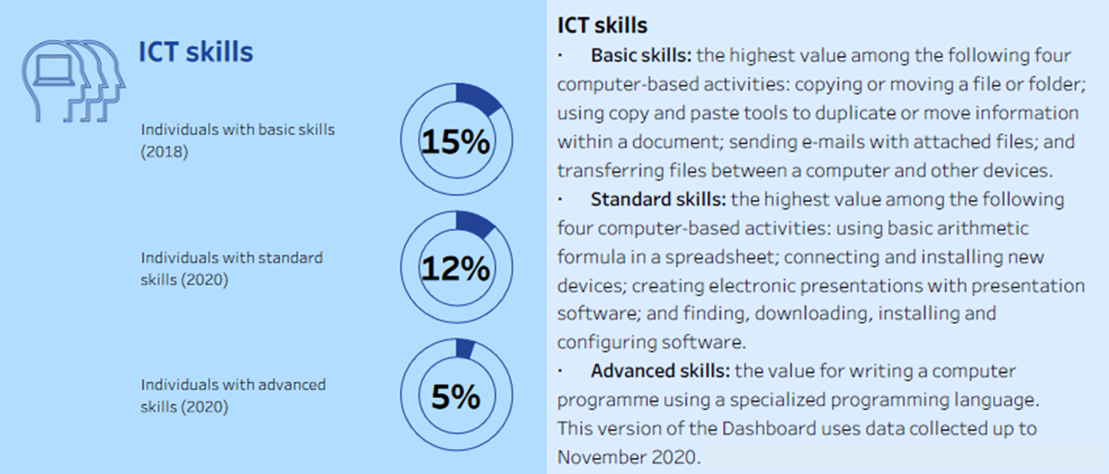
Figure 8: Mongolia ICT Skills (Source: ITU Digital Development Dashboard)
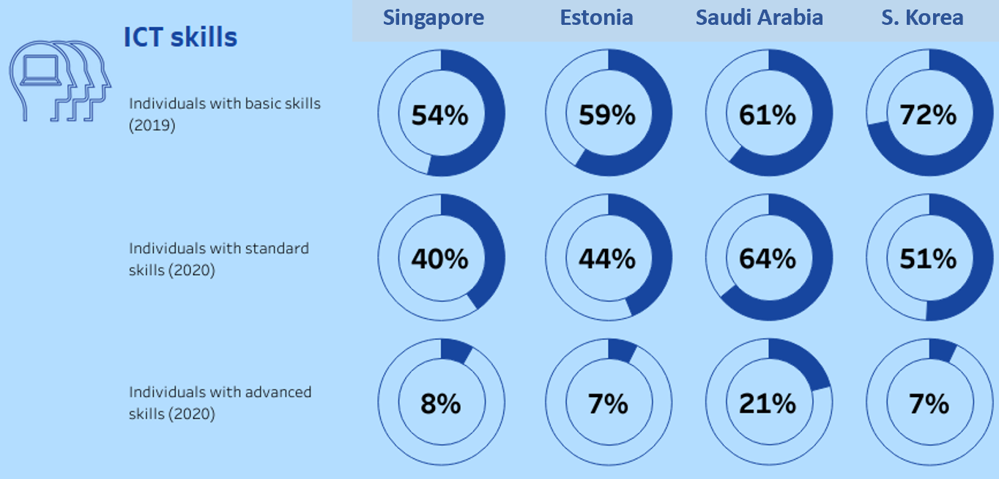
Figure 9: Comparison of Select Countries with Strong ICT Skills (Source: ITU Digital Development Dashboard)

3.3 Mobile Market Structure
Mongolia has a competitive mobile services market. There are four major mobile operators in Mongolia, with about 4.4 million subscribers including 3.6 million mobile broadband subscribers. The estimated subscriber share is shown below:
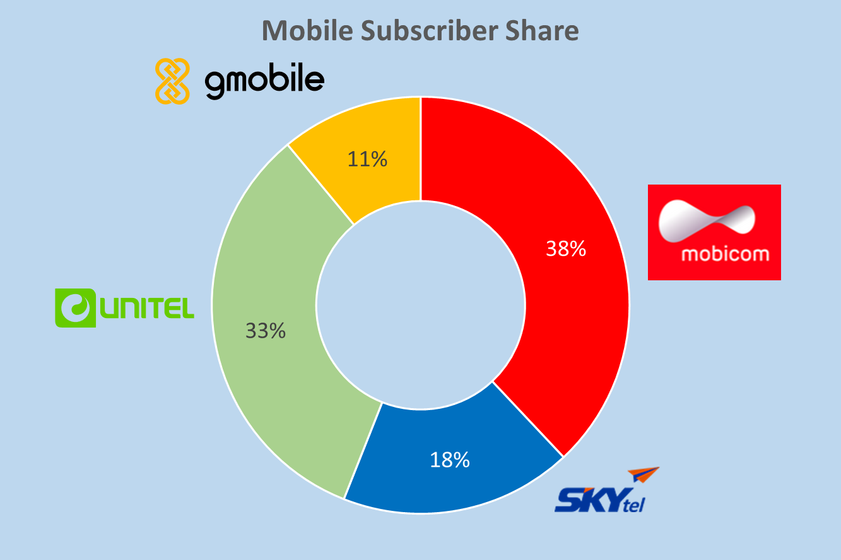
Figure 10: Subscriber Share of Mobile Operators in Mongolia
All four mobile operators offer machine-to-machine (M2M) services but the number of M2M connections remains relatively low – a total of 108,238 in end 2019. In September 2021, a fifth mobile operator – ONDO (registered as IN Mobile Network LLC) – was awarded a licence to provide mobile services. As seen in other markets, a new operator building a mobile network ground up can have many advantages and be very competitive. For example, Reliance Jio in India, Rakuten in Japan and TPG in Singapore have developed networks that are more virtualised and they have no legacy networks to maintain.
At present, ONDO will be focusing on building out a 4G network initially and 5G is not a priority for the company. The other four mobile operators are monitoring the development of 5G and they will require additional spectrum allocation to facilitate the rollout of 5G. This is expected to be in 2023 and beyond. Mobicom started a 5G interoperability trial in March 2021; in partnership with parent company KDDI and Telecom Infra Project (TIP). All four operators appear to be at the early stages of their planning for 5G implementation.
Based on ITU’s Digital Development Dashboard, Mongolia has achieved 100% population coverage for 3G services but 4G services are still being expanded. This suggests that mobile operators’ main focus is on expanding their 4G services before investing in 5G. Nevertheless, it is noted that the mobile phone ownership in Mongolia is relatively high. This underscores the importance of mobile communications in Mongolia, a country where people are distributed across a large land mass.
Figure 11: Mongolia Mobile Infrastructure and Access (Source: ITU Digital Development Dashboard)

3.4 Network Infrastructure
Mongolian fixed-line operators have deployed over 40,000 km of fibre optic cables including backbone networks and metro networks. Information Communications Network (Netcom), a state-owned enterprise, is the leading operator with over 18,000 km of fibre connecting 21 aimags and 373 soums.
Figure 12: Fibre Optic Network in Mongolia (Source: CRC)
As a landlocked country, Mongolia is connected international through an overland cable – Europe-Russia-Mongolia-China (ERMC) cable system. It also relies on satellite connectivity (e.g., Intersputnik, Intelsat and Asiasat) for Internet and communications services. The development of a digital nation will lead to greater reliance on the infrastructure to deliver various mission-critical services. It is crucial for Mongolia to ensure there is sufficient capacity and redundancy to support the growth in traffic volume. For example, an unexpected disruption of the ERMC international cable can result in a severe service outage, since it carries majority of the international traffic. Within the metro areas, the fibre network will also play a crucial role in connecting 5G base stations and the continued investment in fibre network expansion should be encouraged.

3.5 Broadband Services
From the Internet subscription perspective, CRC’s data for 2019 indicate a total of 317,317 fixed-line internet subscribers, majority were fibre-based services. Mobile broadband subscriptions are more than ten times the total fixed-line Internet subscriptions. This highlights the importance of mobile connectivity.
Internet Access | 2019
Mobile Broadband | 3,579,771
DSL | 17,156
Fibre optic | 287,835
Wi-Fi | 10,609
WiMAX | 1,717
Total | 3,897,088
Table 1: Internet Subscriptions
However, there remains a significant gap between the download/upload speeds of fixed and mobile broadband services. The median download speed for fixed broadband is more than three times faster than mobile services, based on the data collected in December 2021 by Speedtest by Ookla. There is also room for Mongolia to improve the mobile broadband speed to improve its global ranking.
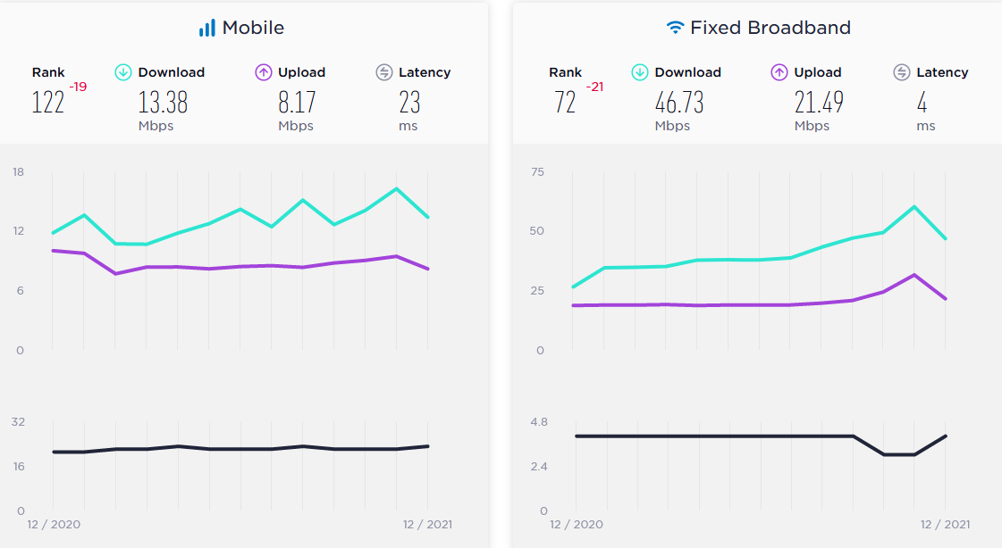

3.6 5G Development in Other Markets
This section considers the development of 5G in selected markets that bear some similarities with Mongolia in terms of population, land area and per capita GDP. As shown in the table below, Mongolia also has higher mobile penetration and average monthly mobile broadband traffic per subscriber than some countries being compared.
Country | Mongolia | Argentina | Kazakhstan | South Africa | Thailand
Population | 3.3 million | 45.8 million | 11.4 million | 60.4 million | 70.1 million
Land Area (km²) | 1.6 million | 2.8 million | 2.7 million | 1.2 million | 0.5 million
Per Capita GDP (nominal) | 4,061 | 8,579 | 9,122 | 5,655 | 7,186
Fixed broadband subs/100 inhabitants | 9 | 21 | 14 | 2 | 17
Active mobile subs/100 inhabitants | 109 | 81 | 84 | 112 | 90
Mobile Download Speed (kbps) | 13.38 | 21.79 | 19.09 | 30.36 | 32.08
Ave. monthly mobile broadband traffic per subscriber (GB) | 5.8 | 1.4 | 10.0 | 2.0 | 20.0
No. of Mobile Network Operators | 4 + ONDO | 3 | 3 | 4 | 5

The table below highlights the progress mobile operators in these markets have made. Besides Thailand, the other three countries have yet to allocate spectrum for 5G; and Thailand’s spectrum allocation does not include 3.5GHz. However, mobile operators in these counties started 5G trials much earlier and have taken steps to deploy 5G, albeit on a small scale except in Thailand.
It is worth noting that like Mongolia, the regulator in South Africa has also been proactive, and taking steps to assess the readiness of the country to support 5G deployment. The regulator is working with industry stakeholders including licensees, equipment suppliers, a standards body, and academia. AIS in Thailand has become a leading 5G operator in the South East Asian region with a strong vision on 5G and engaging different industry partners and enterprise customers to drive 5G-enabled solutions.
Country | 5G Activities
Argentina | The regulator has published a list of 5G spectrum in December 2021 but the timeline for 5G auction has not been disclosed. However, Telecom Argentina’s mobile unit Personal has activated 5G in February 2021, starting with five sites in Buenos Aires; leveraging 4G spectrum and dynamic spectrum sharing (DSS). The company is reportedly extending coverage to the seaside resorts of Mar del Plata, Pinamar and Carilo.
Kazakhstan | All three mobile operators started 5G trials in 2019. Tele2-Altel Kazakhstan launched 5G in central Almaty in September 2021; and Kcell together with partner Ericsson announced the a 5G ‘pre-commercial’ network zone in Turkistan.
South Africa | Vodacom, MTN, Rain and Telkom have also deployed 5G. In 2020, the regulator ICASA had allocated spectrum on a temporary basis for operators to meet increased demands and increased utilisation of spectrum during the COVID-19 pandemic. The operators have since used their existing spectrum for 5G while the 5G spectrum allocation is underway. ICASA has also conducted research to assess the readiness of 5G and identified issues that need to be addressed including spectrum, way leave and right-of-way access, sources of power supply, type approval, FWA for bridging digital divide, cybersecurity risks, etc.
Thailand | Spectrum for 5G was awarded in 2020 (700MHz, 2.6GHz and 26GHz). Three commercial mobile operators (AIS, True and DTAC) have already launched 5G and are actively pursuing partnerships to develop 5G solutions. AIS for example, claims to have 5G coverage in 77 provinces. The company has also deployed 5G SA and developed edge computing and private 5G solutions. This is through working with a range of partners such as: Thai Automation and Robotics Association, Lertvilai and Sons and Yawata for smart factory; Thammasat University to develop autonomous electric vehicles; Huawei, HPE, Microsoft and ZTE to develop MEC solutions; Mitsubishi Electric and TKK to offer 5G smart manufacturing solutions; and more.

4 5G Readiness

The market readiness for 5G is a function of demand and supply. This section analyses four key areas that drive the demand for 5G as well as the ability for the industry to provide 5G services to meet the demand. These areas include the existing telecommunications infrastructure, industry ecosystem, end-user demand and regulations to support 5G. It is also useful to consider the progress of countries that are leading in 5G implementation; and the readiness of these countries from the four aforementioned areas. Based on both 5G speeds and availability, some of the more advanced countries include China, South Korea, the United States, as well as a few major economies in the Middle East (e.g., Qatar, Saudi Arabia and United Arab Emirates) and Northern Europe (e.g., Netherlands, Switzerland and United Kingdom). The economic power, size of the market, and investment in mobile technologies over the years have enabled these countries to stay ahead of others in the 5G race.
Uniquely for 5G, it is also important to consider the ecosystem beyond the mobile operators to support the development of industry-specific applications. 5G supports Industry 4.0 and opens up many new opportunities so the readiness of businesses to adopt 5G-enabled solutions is also an important consideration. It is useful to look at the more advanced markets to identify gaps and areas where Mongolia needs to focus on to speed up 5G implementation and adoption.

4.1 End-User Readiness
From the demand perspective, 5G adoption will be driven by consumers, businesses and government organisations.
Leading Countries | Mongolia
Consumer  Countries leading in 5G implementation typically have high demand for broadband services and have access to faster Internet speeds. This indicates the consumer demand for highspeed broadband services in these markets; and the need for operators to continue investing in their networks to deliver better experience. Based on ITU’s statistics, South Korea, United Arab Emirates (UAE), and the United Kingdom (UK) have very high proportions (i.e., over 96%) of homes and individuals having Internet access. Mobile users in both UAE and South Korea enjoy very fast broadband speeds (median mobile download of above 100Mbps) based on Speedtest Global Index. | Consumer  According to ITU statistics, 47% of homes and 63% individuals in Mongolia have Internet access. This indicates that the need to improve the usage of Internet services and potentially increase the speed of mobile services (4G and/or 5G). This could include FWA services for households.
Business  The adoption of 5G by businesses will drive economic value in terms of productivity and new operating models. The readiness of businesses to adopt 5G is related to their propensity to use technology to drive transformation. For example, businesses that have adopted M2M/Industrial IoT will be more ready to consider using 5G. Major car makers for instance have been early adopters of 5G for transforming their manufacturing operations. Based on OECD data, countries in Western Europe, Japan and the US have high number of M2M connections, for example, the top three countries are 149.5 million in the US, 36.3 million in Germany, and 31.4 million in Japan. | Business  There are currently fewer than 200,000 M2M connections in Mongolia, which is relatively low. During the interview with service providers and CRC, it was apparent that the benefits of 5G were not well understood by the Mongolian business community. This is a common phenomenon in various countries during the early phase of 5G deployment. Businesses will not contemplate 5G solutions until the coverage and services are available; or are being approached by service providers to participate in trials and/or proof-of-concept (PoC) projects.
Government  Government can play a key part in driving the demand for 5G. In general, governments around the world are pushing public services online, including mobile apps (e.g., many countries rolled out mobile apps during COVID-19 for contact tracing, proof of vaccination, health information, etc.). Indirectly, as more people rely on their mobile devices for daily needs, there will be demand for higher speeds and reliability. In addition, government initiatives including smart cities can create demand for 5G services. There are different independent studies on smart cities and ASME for example, called out Dubai as one of the top 10 smart cities. The Digital Dubai Office plays a key role in driving the transformation of the city. Since its inception, the organisation has launched over 130 initiatives including Dubai Data, Dubai Blockchain, Dubai AI Roadmap and Dubai Paperless Strategy. | Government  With the execution of the Digital Nation program, Mongolia will also set itself up as a smart nation. The E-Mongolia is a major milestone and it is expected to lift Mongolia’s E ranking in United Nations E-Government Survey. It is noted that the countries such as Denmark and South Korea that are leading in the E-Government Development Index are also ahead of most countries in 5G implementation (see Figure 13).  Other smart systems and applications will emerge from the program with the uplift of infrastructure and manpower. 5G-enabled smart city solutions are still nascent but use cases are emerging. The Digital Nation will put Mongolia in a good position to benefit from these solutions as they become available.

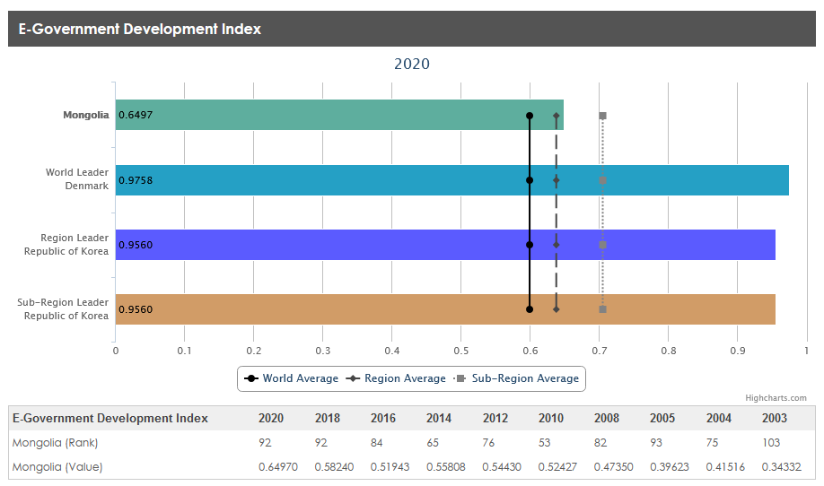
Figure 13: E-Government Development Index (Source: United Nations, Department of Economic and Social Affairs)

4.2 Infrastructure Readiness
To deliver high-speed connectivity, whether it is fibre broadband or 5G wireless, there needs to be a strong telecommunications infrastructure as the foundation. This includes the fibre network that plays a crucial role in providing backhaul connectivity for mobile base stations.
Leading Countries | Mongolia
Fixed Network  Based on the OECD statistics, South Korea, Japan and Sweden are ranked the highest in terms of percentage of fibre connections in total fixed broadband – at over 80%. Speedtest also reports median fixed broadband speeds of over 100 Mbps for both countries in December 2021. Fast Internet speeds are typically dependent on not just the last-mile, but the transmission network as well as the international network (peering and fibre-optic cables). | Fixed Network  Mongolia has a high percentage of fibre connections in total fixed broadband – at above 90%. Fixed broadband speed is also relatively fast as highlighted in Section 3.5. The ongoing expansion of fibre network under the ‘Digital Infrastructure’ is crucial to improve network coverage. Within UB, this can support the backhaul for small cells in hotspots. Mongolia also needs to ensure its international connectivity is able to deliver the capacity and redundancy going forward.
Mobile  The implementation of 5G will involve many small cells especially in high traffic hotspots using mmWave. Mobile operators rolling out 5G are also looking at various technologies such as dynamic spectrum sharing (DSS), carrier aggregation and massive MIMO. Mobile operators have also deployed IoT networks (NB-IoT, LTE-M /Cat-M1, etc.) to support various industry use cases.  More advanced mobile operators have also collaborated with competitors to share infrastructure to lower the cost. This includes sharing of both passive and active infrastructure. Some of them (e.g., Vodafone) have also implemented 5G Open RAN to work with a broader range of suppliers and drive innovation. | Mobile  Mobile operators in Mongolia have not deployed small cells extensively due to the lower population density. The development of IoT is also at a relatively early stage. However, these will change as operators implement 5G and will need capacity for places such as stadium and shopping malls; and support various smart city and industrial IoT use cases.  Mobile operators do share passive infrastructure on a case-by-case basis. Some operators support infrastructure sharing for more sustainable and affordable 5G deployment. There have not been regulatory initiatives to support sharing.

4.3 Industry Readiness
The mobile operators will remain the key industry players in offering 5G services especially to consumers. However, in meeting the needs of enterprise applications, a broader ecosystem of players to drive adoption is essential. Advanced countries such as China, Japan, South Korea and the US have strong R&D and equipment manufacturers that are the key promoters of 5G. But these manufacturers also need to work with other partners to bring 5G solutions to the market. For example, the system integrators are well placed to engage enterprise customers to integrate connectivity with applications and business processes. The hyperscale cloud providers are bringing their cloud capabilities to mobile edge in the form of multi-access edge computing (MEC). The device makers (e.g., wearables, AR/VR gear), independent software vendors (ISVs) and platform providers are all crucial part of the ecosystem.
Leading Countries | Mongolia
Mobile Operators  The mobile services market is highly competitive which means operators cannot afford to fall behind their rivals. Before the launch of 5G, mobile operators had worked closely with equipment vendors to conduct trials to explore the capabilities of 5G and develop the business case.  More advanced mobile operators are also developing 5G enterprise solutions with partners; recognising the limitation of driving innovation in-house. For example, T-Mobile in the US collaborates with 5G Open Innovation Lab, CoMotion and University of Washington to enable hardware start-ups to develop test and roll out new products, services, and prototypes powered by T-Mobile’s 5G network. | Mobile Operators  Mobicom and Unitel have conducted 5G trial to assess 5G capabilities. The collaboration is mainly with 5G vendors. Overall, operators are uncertain about the business case for 5G. The mobile operators see potential in support industry applications in areas such as mining and transportation but believe the market is still nascent.
Other Players  Other players have also seen the opportunities to develop solutions leveraging 5G capabilities. As highlighted earlier, AWS has introduced Wavelength, which embeds its cloud compute and storage within 5G networks. In partnership with KDDI, SK Telecom, Verizon and Vodafone, AWS Wavelength is now available in Japan (Tokyo), South Korea (Seoul), the UK (London), and the US (North Virginia and Oregon) respectively.  In developing MEC solutions, Vodafone and AWS had created an incubation program – Vodafone Business Edge Innovation Program – to attract start-ups, ISVs, businesses and developers to develop, test and deploy a proof-of-concept (PoC) 5G application. Several applications have emerged from the program including Xpllore’s VR solution to help improve the way people learn, design and communicate.  System integrator Tech Mahindra has partnered with Nokia to drive 5G private wireless adoption globally. In the US, WCI Technologies also partners with Dish Network to use the latter’s spectrum for private wireless deployments. | Other Players  There has not been much industry collaboration in exploring 5G. Without the 5G network and clarity on the availability of 5G services, there is no motivation for industry players to start considering the possibilities with 5G. There is also a general lack of awareness across the industry.

4.4 Regulatory Readiness
Regulations play an important role in enabling 5G implementation. This includes issuing the necessary licences and additional spectrum. Regulators can also shape competition and influence investments through spectrum allocations, network access conditions, and infrastructure sharing. Regulators can also play an active role in setting policies and putting in place rules and practices to facilitate the deployment of 5G as well as the adoption of 5G services.
Leading Countries | Mongolia
5G Spectrum Allocation  Additional spectrum especially in the mid-band (3.5GHz) for mobile operators to kick-start 5G deployment. In addition, countries with leading 5G agendas have also ensured the availability of spectrum for different scenarios:  - made spectrum in the mmWave available for operators to develop high bandwidth applications;  - made available spectrum in the low-band (below 1GHz) to achieve better coverage especially in sparsely populated areas;  - allowed operators to refarm existing spectrum for 5G;  - allocated spectrum to support private 5G networks; and  - provided an indication of future spectrum in the roadmap. | 5G Spectrum Allocation  CRC is planning to allocate 5G spectrum in 2023. It has identified 1220 MHz of spectrum including mid-band spectrum (e.g., 3400 – 4000 MHz and 4400 – 5000 MHz) and mmWave. This is adequate to give all the operators additional 100MHz in the mid-band for 5G rollout. CRC will also allow new participants, if any, to access the spectrum to offer 5G services.  There are also plans to allow mobile operators to transfer their existing spectrum, including the low-band spectrum, to 5G from 2024 onwards.
5G Licensing and Conditions  There are regulations and licence conditions designed for previous generations of mobile technology. For example, regulators have updated the licensing conditions to ensure that:  - associated licence fees including spectrum charges are not overly burdensome for operators;  - the quality of service (QoS) requirements are updated (e.g., operators will take years to complete the 5G rollout and will depend on existing 2G/3G/4G to meet coverage requirements; and  - licence conditions do not inhibit infrastructure sharing.  Some regulators have also stepped in to remove impediments to 5G deployments. For example, the FCC in the US has updated its infrastructure policy to speed up 5G small cell siting applications, and to update rules governing the attachment of new network equipment to utility poles. It is also FCC’s policy to promote 5G backhaul and encourage the investment in fibre network. | 5G Licensing and Conditions  The Mongolian government has adopted a set of policy guidelines to facilitate the implementation of 5G. Under the guidelines, CRC will issue 5G licences in 2023 and will address spectrum issues as well as resolve potential licensing issues including licence fees, royalty payments, and regulatory service fee.
Security  The 5G network is a critical infrastructure that will be used to connect other critical infrastructure including utilities, transportation, smart cities, etc. Cyber threats are already prevalent impacting network infrastructure, applications and services. With more government and enterprise networks connected via 5G, the network infrastructure will provide cyber-criminals a larger attack surface.  Policymakers in countries that aim to harness the power of 5G are actively collaborating with the industry (including telecom operators) to have shared goals of managing cybersecurity risks and attacks. This requires a holistic approach to manage risks across supply chain, devices, data protection, cyber intelligence, etc. | Security  Information security is a key pillar of Mongolia’s Digital Nation program. The goal is to establish a national information security system; an e-signature infrastructure; and a cyber security response and recovery capability.
Rural Infrastructure  It may not be commercially viable to extend 5G to rural areas. To close the digital gap, some countries have seen cooperation among operators and/or government funding the development of 5G in rural areas.  Cooperation among operators to share network infrastructure is becoming common, and regulators have been supporting of such moves. For example, in South Korea, the Ministry of Science and ICT supported the sharing of infrastructure among the three MNOs – SK Telecom, KT and LG Uplus – in remote coastal and farm towns. In the US, the FCC’s 5G Fund for Rural America established in October 2020 will provide $9 billion in Universal Service Fund to support the deployment of 5G in rural America. | Rural Infrastructure  Under the Digital Nation program, the Digital Infrastructure initiative encompasses the connection of rural areas. However, the initial focus for 5G is in UB. 5G in rural areas can be achieved faster and at a lower capital investment through infrastructure sharing arrangements.

5 Gap Analysis
Objectives | Current Situation | Gap | Recommended Actions
End-user
- High availability of high-speed broadband services, including the rural community, will drive demand for 5G services.  - Business should start exploring 5G-enabled use cases  - Government should be looking to use 5G to improve public services and drive smart city projects | - More can be done to increase the broadband penetration and the speed of mobile broadband services  - The operators do not yet have a strong M2M/IoT business  - The Digital Nation program has started driving the digitisation of public services | - There is a lack of awareness among businesses with regard to availability and capabilities of 5G  - The operators have not been working with businesses to explore potential 5G solutions.  - The adoption of industrial IoT is relatively low compared to countries that are ahead in the 5G race  - There has yet been a comprehensive smart city program in place | - Mobile operators and regulators can jointly conduct workshops to increase awareness of 5G among businesses and government organisations  - Co-creation of 5G solutions with major enterprises; and promote industrial automation through IoT solutions  - Leverage 5G trial system to engage interested businesses to test industry use cases and conduct PoC  - Include smart city solutions to the Digital Nation program
Infrastructure
- The fixed network needs to have the capacity, coverage and resiliency to support 5G requirements including the backhaul for base stations  - The adoption of technologies such as DSS, massive MIMO, Open RAN, etc. can enable a more flexible and higher capacity 5G network  - Easy access to alternative sites (e.g., utility poles) for small cells | - Mongolia has an existing fibre network that delivers high-speed broadband services; and the network continues to expand  - Mobile operators are focusing on improving their 4G services in terms of coverage and speed  - Only Mobicom and Unitel have conducted 5G trials; and 5G deployment is expected to commence in 2023 | - There is a lack of diversity in international connectivity  - The broadband services for rural areas can be improved  - The mobile broadband speed is not fast at the global level, based on benchmarking done by Ookla  - There has not been extensive use of small cells in Mongolia | - Consider the issue of redundancy for international capacity as part of the Digital Infrastructure initiative  - Consider infrastructure sharing to speed up the deployment of 5G in rural areas  - Encourage the migration of mobile customers from 2G/3G to 4G/5G to free up spectrum for 5G mobile broadband and/or FWA
Industry
- A 5G ecosystem comprising mobile operators, hardware vendors, software vendors, developers, R&D organisations, cloud service providers, etc. is crucial to drive the development of 5G solutions for Mongolia. | - The preparation for 5G is still at an early stage.  - Mobicom and Unitel has conducted 5G trial; but G-Mobile and Skytel have not started a trial | - There is a lack of collaboration within the industry to explore 5G solutions | - Encourage collaboration between mobile operators and academia in building 5G expertise and solutions tailored to the local needs  - Organise industry forums to facilitate operators and other industry players to drive the development of 5G applications and solutions  - A 5G forum comprising industry stakeholders can also help provide feedback to the regulator on potential hurdles for 5G deployment
Regulatory
- Spectrum for 5G is awarded sooner rather than later  - Mobile operators have the flexibility to refarm existing spectrum for 5G  - The licensing terms and conditions should not adversely impact operators’ business cases for 5G  - Regulatory intervention where necessary to strengthen infrastructure security and facilitate the rollout of 5G (e.g., site acquisition and infrastructure sharing) | - Policy guidelines for 5G have been established  - Spectrum allocation for 5G is planned for 2023; with sufficient spectrum for existing and new operators  - While low-band spectrum is not part of the allocation, operators will be allowed to transfer existing spectrum to 5G from 2024 onwards  - 5G licensing is under review as part of the policy direction | - Spectrum has not been awarded for 5G. The spectrum allocation timeline sets the pace for mobile operators’ 5G planning  - 5G licensing framework has not been finalised and operators are not able to use existing spectrum for 5G | - Consider allowing operators to use existing spectrum for 5G to speed up the migration of legacy services  - Develop a framework to facilitate the implementation of small cells including indoor systems and outdoor facilities (e.g., lamp posts)  - Coordinate with various government bodies to ensure that site access and planning requirements are not a barrier to the deployment of 5G

6 Summary and Recommendations

The imperative for mobile operators in Mongolia is to enhance their 4G coverage to offer mobile broadband services to more people. There does not appear to urgency for mobile operators to deploy 5G since spectrum and licensing will only take place in 2023 and the business case is still unclear. Unlike previous generations of mobile technologies, 5G is not just about delivering more and enhanced services for consumers. New 5G solutions are also not developed among mobile operators and traditional mobile equipment vendors; but through a wider industry ecosystem. As highlighted in this report, operators in developed and emerging markets see transitioning to 5G as inevitable and many are keen to take the lead to gain competitive advantages. Some of the leading operators are starting to realise the benefits highlighted in Section 2.4 of this report.
The first 5G networks were launched about three years ago in 2019 in countries such as South Korea and the US. However, countries leading in the 5G race still have much to do. Having the coverage and offering 5G devices are just the first steps but there has been limited revenue upside from mobile subscriptions since markets are becoming saturated. To offer better services to win market share also means the need to bring in new technologies (e.g., massive MIMO, mmWave and carrier aggregation) to offer faster connectivity. The ability to offer FWA brings additional revenues but mobile operators see greater opportunities in industry transformation. Hence, while mobile operators continue to expanding their 5G coverage and enhancing the speeds, there is also a strong focus in developing new enterprise solutions together with various technology partners and enterprise customers.
Without a concerted effort, 5G implementation can take much longer to benefit the Mongolian society and economy. Without planning and preparation in advance, operators will encounter the same challenges as their counterparts in other countries once they have the spectrum and licence: how to gain new revenue streams with the new investments?
On the positive side, there has already been a lot of development around the world and new 5G-enabled solutions are emerging. This will shorten the learning curve for Mongolian operators. Globally, mobile operators are expanding their partnership ecosystems and building new capabilities to capture the emerging opportunities. Moreover, there are ways mobile operators are improving their cost structures by transforming their networks; and through sharing of infrastructure. In many ways, 5G is helping mobile operators to transform themselves as much as enabling the transformation of other industries.

6.1 Accelerating the Development of 5G
It is ideal to award 5G spectrum and licences to mobile operators earlier rather than later. However, there are various steps that can be organised in the meantime to speed up the rollout and adoption 5G.
Allow 5G with Existing Spectrum: While it may take time for the designated 5G spectrum to become available in 2023, CRC can consider allowing operators to refarm existing spectrum for 5G. This will encourage mobile operators to accelerate the migration of customers from the legacy network to 4G/5G and improve the efficiency of spectrum utilisation. This is particularly crucial in the low-band (sub-1 GHz) where spectrum is tied up for existing mobile services. The low-band is important for coverage especially in sparsely populated areas as well as for building penetration. In a competitive market, the fear-of-missing-out (FOMO) factor can motivate operators to act faster.
5G Trials to Go Beyond Testing Speeds: The initial phase for many mobile operators in 5G development had been to test the capabilities of 5G for network planning and for developing the business case. It is recommended that the mobile operators keep the trial system live, and extend it to external parties for innovation. This is necessary for academia to develop 5G applications as well as for mobile operators to work with industry partners and enterprise customers to develop PoCs. In many cases, enterprises need to conduct a PoC to assess the business benefits before committing to the investment. For example, Singtel in Singapore has introduced a portable 5G platform that allows enterprises to experience 5G, and test use cases in their own premises Besides the radio access, there are other elements such as multi-access edge computing, Open RAN, mmWave-enabled small cells, and network slicing which can form part of the trial initiatives.
Infrastructure Sharing: The tendency is for mobile operators to focus on UB where people are more likely to be able to afford 5G devices. The deployment of 5G in sparsely populated area is commercially less viable, especially with limited low-band spectrum available. It is recommended that infrastructure sharing be explored for the rural areas. Mobile operators appear to be keen to explore infrastructure sharing to lower the cost of 5G rollout. This is already adopted by operators in other countries, in both developed and emerging markets. The infrastructure sharing includes passive and active components (RAN and spectrum). It is necessary to ensure that the spectrum licence conditions do not inhibit the sharing of spectrum as part of the infrastructure sharing arrangement.

6.2 The Regulator Can Take the Lead
From the advanced markets such as the US to the emerging markets such as Brunei and South Africa, regulators are keen to facilitate the implementation of 5G. There are various ways the Ministry of Digital Development and Communications and CRC can facilitate the implementation and adoption of 5G as highlighted in the Gap Analysis. It is recommended that a special committee or taskforce can be established to drive these initiatives. The work of this committee/taskforce will also be well aligned to the six goals of the Digital Nation program. It is further recommended that the committee/taskforce is divided into four working groups to undertake these objectives:
- The Policy & Regulations Working Group will focus on:
  - Determining the spectrum requirements, allocation process and mechanism; as well as spectrum sharing regulations.
  - Review licensing conditions for 5G including fees, QoS, services allowed, etc.; and the type approval of 5G equipment (including IoT devices and customer premise equipment for businesses).
  - Review existing policy and processes that could potentially delay the development of 5G services.
- The Infrastructure Working Group will need to involve stakeholders from relevant government bodies as well as industry stakeholders. This is aligned with the digital infrastructure and information security goals of Digital Nation. The group will be responsible for:
  - Review processes for the installation of 5G base stations within buildings, as well as external structures including rooftop space, new towers, and street furniture (e.g., bus stops, lamp post, utility poles, etc.).
  - Assess the risks to 5G infrastructure and develop the security framework for securing the infrastructure. This will require partnership between government agencies and the industry.
  - Facilitate infrastructure sharing, especially in the rural areas, and develop the guidelines for sharing.
  - Take into consideration the requirements for 5G in the digital infrastructure planning. This should include the fibre access for mobile backhaul, as well as the network resiliency for transmission lines and international connectivity.
- The Industry Development Working Group will help to develop a 5G ecosystem within Mongolia. This is aligned with the innovation and production and e-governance goal of Digital Nation:
  - Provide incentives (e.g., access to expertise, market access, funding) to encourage start-ups and entrepreneurs to develop 5G applications and solutions.
  - Attract technology firms from overseas to work with mobile operators to trial use cases for the Mongolian market.
  - Identify opportunities within public services to streamline operations through 5G. This should cover various smart city solutions.
  - Facilitate co-innovation among mobile operators, technology firms, enterprises and the academia to develop 5G solutions tailored to the local needs.
- The Education Working Group will drive awareness of 5G and develop the skills needed to support the industry. This is aligned with the digital literacy and national development accelerator goals of Digital Nation.
  - Create awareness among enterprises in key industries (e.g., mining, transportation, utilities, etc.) the benefits of 5G and potential use cases.
  - Collaborate with the academia in developing training and research program in the 5G field. This is to develop local expertise and it should also include the development of applications and solutions for 5G through partnerships with mobile operators.

GSA, 2021. 2021 Review: 5G Spectrum, networks and devices.
Ericsson, 2021. Ericsson Mobility Report. https://www.ericsson.com/en/reports-and-papers/mobility-report/dataforecasts/network-coverage
Ditto
GSMA. Global Launches and Statistics. https://www.gsma.com/futurenetworks/ip_services/understanding-5g/5g-innovation/
GSA, 2021. 2021 Review: 5G Spectrum, networks and devices.
PwC, 2021. The global economic impact of 5G. https://www.pwc.com/gx/en/industries/technology/publications/economic-impact-5g.html
Nokia, 2021. Here is why mining is digging into 5G. https://www.nokia.com/blog/here-is-why-mining-is-digging-into-5g/
Opensignal, 2021. Understanding the mobile experience on T-Mobile’s standalone 5G network. https://www.opensignal.com/2021/02/18/understanding-the-mobile-experience-on-t-mobiles-standalone-5g-network
Ditto
Telstra, 2018. 5G: where promise meets reality. https://exchange.telstra.com.au/5g-3gpp-where-promise-meets-reality/
Microsoft, 2021. AT&T to run its mobility network on Microsoft’s Azure for Operators cloud, delivering cost-efficient 5G services at scale. https://news.microsoft.com/2021/06/30/att-to-run-its-mobility-network-on-microsofts-azure-for-operators-cloud-delivering-cost-efficient-5g-services-at-scale/
Nokia, 2021. Nokia and Google Cloud partner to develop new, cloud-based 5G radio solutions. https://www.nokia.com/about-us/news/releases/2021/03/15/nokia-and-google-cloud-partner-to-develop-new-cloud-based-5g-radio-solutions/
AWS Wavelength Zone Locations. https://aws.amazon.com/wavelength/locations/
Telefonica. Telefónica Tech partners with Microsoft to provide the industrial sector with private 5G connectivity and on-premises edge computing. May 2021. https://www.telefonica.com/en/communication-room/telefonica-tech-partners-with-microsoft-to-provide-the-industrial-sector-with-private-5g-connectivity-and-on-premises-edge-computing/
NewsMN, 2021. Mongolia fast-tracking digital government. https://news.mn/en/795578/
World Economic Forum, 2020.The Global Competitiveness Report. https://www3.weforum.org/docs/WEF_TheGlobalCompetitivenessReport2020.pdf
ITU, 2020. Mobile-cellular subscriptions. https://www.itu.int/en/ITU-D/Statistics/Documents/statistics/2021/July/MobileCellularSubscriptions_2000-2020.xlsx
ITU, 2020. Mobile-broadband subscriptions. https://www.itu.int/en/ITU-D/Statistics/Documents/statistics/2021/July/MobileBroadbandSubscriptions_2007-2020.xlsx
Communication Regulatory Commission of Mongolia, 2020. Main Indicators of ICT Sector Fiscal Year 2019.
Speedtest by Ookla. December 2021. Mongolia's Mobile and Fixed Broadband Internet Speeds. https://www.speedtest.net/global-index/mongolia
The World Bank. https://data.worldbank.org/indicator/NY.GDP.PCAP.CD?most_recent_value_desc=true
ITU. Digital Development Dashboard. https://www.itu.int/en/ITU-D/Statistics/Dashboards/Pages/Digital-Development.aspx
Ditto
Speedtest, December 2021. https://www.speedtest.net/global-index/
ITU. Digital Development Dashboard. https://www.itu.int/en/ITU-D/Statistics/Dashboards/Pages/Digital-Development.aspx
ICASA, 2021. The State of 5G in South Africa 2021. https://www.icasa.org.za/uploads/files/ICASA-2021-5G-Annual-Report.pdf
AIS. Coverage. https://www.ais.th/5g/en/coverage.html?intcid=5gindex-en-banner-coverage
AIS. News Release. https://investor.ais.co.th/newsroom_press.html
Ookla Speedtest, 2021. Growing and Slowing: The State of 5G Worldwide in 2021. https://www.speedtest.net/insights/blog/state-of-worldwide-5g-2021/
ITU, 2020. Core indicators on access to and use of ICT by households and individuals https://www.itu.int/en/ITU-D/Statistics/Documents/statistics/2021/July/CoreHouseholdIndicators.xls
Speedtest by Ookla, December 2021. Speedtest Global Index. https://www.speedtest.net/global-index/
OECD, 2020. M2M/embedded mobile cellular subscriptions. https://www.oecd.org/sti/broadband/1.12-M2M-2020-12_Final.xls
ASME, 2020. Top 10 Growing Smart Cities. https://www.asme.org/topics-resources/content/top-10-growing-smart-cities
Digital Dubai Office. https://www.digitaldubai.ae/initiatives
Vodafone, 2021. Vodafone switches on UK’s first 5G Open RAN site. https://www.vodafone.com/news/technology/5g-open-ran-first-uk-site
T-Mobile, 2021. 5G Open Innovation Lab, CoMotion at the University of Washington and T‑Mobile Collaborate to Accelerate 5G Hardware Innovation. https://www.t-mobile.com/news/network/5g-oilab-comotion-t-mobile-accelerate-5g-hardware-innovation
AWS Wavelength Zone Locations. https://aws.amazon.com/wavelength/locations/
AWS, 2020. AWS and Vodafone Business Bring Edge Computing Closer to Organizations in Europe. https://aws.amazon.com/blogs/industries/aws-and-vodafone-business-bring-edge-computing-closer-to-organizations-in-europe/
Vodafone. With Vodafone 5G, Xpllore can revolutionise learning through immersive experiences. https://www.vodafone.co.uk/business/5g-for-business/5g-customer-stories/xpllore
WCI Technologies, 2022. WCI Technologies Partners with DISH to Market 5G for Enterprises. https://www.prnewswire.com/news-releases/wci-technologies-partners-with-dish-to-market-5g-for-enterprises-301462617.html
FCC. The FCC’s 5G FAST Plan. https://docs.fcc.gov/public/attachments/DOC-354326A1.pdf
Telegeograph, 2021. South Korean cellcos to share 5G infrastructure in rural areas. https://www.commsupdate.com/articles/2021/04/15/south-korean-cellcos-to-share-5g-infrastructure-in-rural-areas/
FCC. https://www.fcc.gov/5G
Singtel, 2021. Singtel launches GENIE, world’s first portable 5G-in-a-box platform to accelerate 5G innovation. https://www.singtel.com/about-us/media-centre/news-releases/singtel-launches-genie

