**Long-term trends in livestock and wildlife interactions: do livestock numbers predict hunting of wolves, foxes, and rodents in Mongolian rangelands?**

Gantulga GANKHUYAG1, Francisco CEACERO2,*, Adiya YANSANJAV1, Pavla HEJCMANOVÁ2, Lkhagvasuren DAVAA3, Sainbileg NAMKHAIDORJ4, Barbora ČERNÁ-BOLFÍKOVÁ2.

1 Institution of General and Experimental Biology, Mongolian Academy of Sciences, Ulaanbaatar, Mongolia.

2 Faculty of Tropical AgriSciences, Czech University of Life Sciences Prague, Prague, Czech Republic.

3 Department of Biology, School of Arts and Sciences, National University of Mongolia, Ulaanbaatar, Mongolia.

4 Inner Mongolia University, Hohhot, China.

* Corresponding author.

**Running title:** Long-term interactions between livestock and wildlife numbers

**ABSTRACT**

Xxx

**Keywords:** xxx

**INTRODUCTION**

For thousands years, nomadic people have been using the Mongolian plateau as pastureland. This vast and boundless land also hosts some of the largest populations of terrestrial wild ungulates, and other endemic and unique species diversity have been co-existing with nomadism until recent time. However, the numbers of domestic livestock have been dramatically increasing during the last three decades (Mongolian Statistical Information Service, 2019), threatening this long-term existing co-existence. In recent years, several studies have shown how competition, pasture degradation and overgrazing influence the populations of wild ungulates (Campos-Arceiz et al., 2004; Yoshihara et al., 2008; Olson et al., 2011; Sheremetev et al., 2017; Takatsuki et al., 2018; Sugimoto et al., 2018). However, few of them have considered further potential impacts on other wildlife species, like predators, or though modifications in the ecosystems.

Wolves (*Canis lupus*) are clearly one of the most sensible species to changes in the number of livestock and wild ungulates, since both are potential preys (Clark et al., 2006; Davie et al., 2014). Abundance of wolves in Mongolia has never been studied but it is believed they drastically decreased in population sizes due to hunting (Wingard and Zahler, 2006). It is the most widely distributed large predator in Mongolia (Batsaikhan et al., 2014), although their range has considerably decreased allegedly due to habitat changes and hunting (Mech and Boitani, 2010) since they are viewed as a threat to livestock and livelihoods in many areas (Boitani and Ciucci, 2009). Still, wolves continue to be important ecologically by influencing biodiversity, community structure, and ecosystem functions (Beschta and Ripple, 2010), while they are at the same time hunted for sport, profit, and to control predation on livestock (Davie et al., 2014). According to IUCN, wolves in Mongolia are near threatened but the knowledge about the population trends is missing completely (Clark et al., 2006).

Burrowing rodents like marmots (*Marmota* sp.) and ground squirrels (*Spermophylus* sp.) are, together with livestock and wild ungulates, the main animal modifiers of the Mongolian steppe ecosystems with complementary roles (Yoshihara et al., 2010a, 2010b). Thus, changes in the community of grazers may positively or negatively affect the suitability of the habitat for them. Furthermore, changes in the community of large rodents must affect their main predators, like red (*Vulpes vulpes*) or corsac (*Vulpes corsac*) foxes.

Hunting organizations were established in each Mongolia’s province (smaller administrative districts in Mongolia) around 1930s, in order to derive economic benefits from commercial harvesting (Reading et al., 1998). Following the collapse of the Soviet state in the late 80s, there are no longer official hunting records. A nationwide survey involving nearly 1,000 Mongolian hunters reported the killing of over 1,770 wolves in 2004 (Wingard and Zahler, 2006). Recent declines of species like argali sheep (*Ovis ammon*), Mongolian gazelle (*Procapra gutturosa*), black-tailed gazelle (*Gazella subgutturosa*), and red deer (*Cervus elaphus*) have been also reported. The causes of decline have been attributed to several factors like infrastructure development, conversion of habitat for agriculture, overgrazing, competition for forage, and mining. Still, the most serious and immediate threat is considered to be overhunting, most of it illegal (Wingard and Zahler, 2006). On the other hand, if the livestock growth still continues without any management or legislation, it might drive to biodiversity losses in the area.

Given the numerous interactions between livestock and wildlife already described, our aim was to examine how the livestock population numbers have historically influenced wildlife population trends (namely for wolves, foxes, and rodents) over a 45 years’ period (1941-1985) by using official hunting statistics as an indicator of population abundance. Then, we used predictive models to reveal how the recent sharp increase in livestock numbers should have affected the dynamics of these selected species, and which are the potential consequences on the biodiversity of Mongolian rangelands.

**MATERIALS AND METHODS**

***Study area***

Mongolia is a land-locked country in Central Asia, covering an area of 1.6 million km2 and divided into steppe, boreal forest, taiga forest, high mountains, and Gobi-desert ecosystems. The main characteristics of the climate of Mongolia are mostly sunny days, long and cold winters, low precipitation and large annual, seasonal, monthly and diurnal fluctuations in air temperature. The total annual precipitation in desert-steppe are less than 100mm, in the steppe from 150 to 250 millimetres and in the mountainous regions averages 400mm. Around 80 % of the precipitation falls during the three summer months. The annual average temperature increased by 2.14ºC between 1940 and 2008 in Mongolia (Gombobaatar and Conaboy, 2014).

***Data collection***

We obtained commercial hunting data from 1940 to 1987 from the former Ministry of Trade and Development. The responsible section of this Ministry has since been transferred to the new Ministry for Nature and the Environment. We used commercial hunting data of grey wolf, red fox, corsac fox, marmot and ground squirrel species at 22 provinces, including Ulaanbaatar. Mongolia transitioned to democracy in 1989, around the same time that the Soviet Union collapsed. At this time, commercial hunting organizations were stopped, and after that, reliable hunting data for whole country, region or province levels are not available anymore. Hunting of grey wolf, red fox, corsac fox, and marmots has been traditionally organized throughout the year based on the behaviour and activity of each species.

The data on annual livestock numbers for each province for the period between 1940 and 1948 were obtained from (Pechnikov, 1949). The data on annual livestock numbers from 1949 to 1969 were obtained from the National Statistics Office of Mongolia, stored in the Mongolian National Central Archives. From 1970 to 2017, official annual livestock data were collected (Mongolian Statistical Information Service, 2019). Based on national statistics there are more than 66 million livestock. Following the Soviet Union collapse in Mongolia in the early 1990s, numbers of managed livestock increased as people prefer to herd in the countryside (Reading et al., 2006).

***Statistical analyses***

Since the database for hunted animals had several missing values, the data was grouped as average for each 5-y period, starting from 1941 (*i.e.*, 1941-45, 1946-50, etc.) Data until 1985 were used to build predictive models explaining the influence of livestock data on hunting data. Generalized Estimating Equations were used, with province as subject and each 5-y period as repeated measure. Poisson log linear function was used. An hybrid method for parameter estimation was used, in which Fisher scoring iterations are performed before switching to the Newton-Raphson method (in case that convergence is not achieved during the Fisher scoring phase). Type III model effects were calculated, since these are more generally applicable than Type I; Wald statistic and Full Log quasi-likelihood function were used for their determination. Models for each studied hunted species were selected based on Quasi-Likelihood under the Independence Model Criterion (QIC; for choosing the best correlation structure) and Corrected Quasi-likelihood under Independence Model Criterion (QICC; for choosing the best subset of predictors). Predicted values were saved for each model.

Based on the previously described models, total predicted numbers of hunted individuals were thereafter calculated for each studied species and for each province. We used this information to calculate the evolution of hunting data in the whole country (average for all provinces) for two periods: the one based on actual data (from 1941-45 to 1981-85) and the one estimated from the models (from 1986-90 to 2011-2015).

Finally, Pearson correlations showed the tendency for each province and for each of the hunted species studied during the estimated period. Data from the last observed period (1980-85) was also included in the analyses as starting point for the predictions done by the models.

All analyses were performed in IBM© SPSS© version 25.

**RESULTS**

Figure 1 shows the evolution of livestock data in Mongolia in the period 1941-2015, showing a relatively stable scenario until 1990. Before that, the only relevant change happened in the period 1941-1955, when goats and especially sheep largely substituted the horses herd. However, in the period from 1995 to 2015 the herd has doubled, being sheep and especially goat the species that have increased in greater numbers.

For all the hunted species studied, the full model was always selected according to their QIC and QICC values, even if some of the parameters were not significant. These models are shown in Table 1. The significant effects detected between livestock and hunting data were mainly positive; however, the population of goats affected negatively the amount of hunted wolves, while the number of camels affected negatively the number of hunted marmots.

The models previously described were used to estimate hunting data for the period 1985-2015. Overall, the estimations show a sharp decline in the predicted hunting numbers of two predators (wolves and Corsac foxes), all along the country (Figures 2a and 2b), but an increase in the expected hunting of red foxes, ground squirrels and marmots (Figures 2c, 2d, 2e). By province, the estimation of hunted wolves’ declines strongly in all them, being highly significant (p<0.01) in Dornogobi, Gobisumber, Khentii and Sukhbaatar, and significant (p<0.05) in all others except Bayan-Ulgii, Darkhan-Uul, Orkhon and Ulaanbaatar (Figure 3 for this and following results). Results are very similar for the estimated hunting of corsac fox: highly significant decline in Gobisumber, Khentii and Sukhbaatar, and just significant in Arkhangai, Bayankhongor, Bulgan, Dornod, Dornogobi, Khovd, Khuvsgul, Selenge, Tuv, Uvs and Zavkhan. Estimated red fox hunting tended to increase in all the provinces, but significantly only in Arkhangai, Bayankhongor, Bulgan, Gobisumber, Khentii, Khuvsgul, Selenge, Sukhbaatar, Tuv and Uvurkhangai. Estimated hunting of ground squirrels showed a highly significant increase in Bayankhongor and Darkhan-Uul, and significant in Arkhangai, Dornod, Gobisumber, Khuvsgul and Selenge. Finally, the estimated hunting of marmots increases with higher significance in Bayankhongor, and significantly in Arkangai, Bulgan, Darkhan-Uul, Dornod, Dornogobi, Gobisumber, Khentii, Khuvsgul, Selenge, Sukhbaatar and Tuv.

**DISCUSSION**

The livestock herd in Mongolian stepped has changed in the past and continue changing drastically in the recent decades. The most dynamic changes have affected horse (in the past) and goat and sheep numbers (recently): the first dramatically decreased between 1940 and 1955 and then remained at low levels; the latter increased in turn, then remaining high and rapidly increasing again since 1995. Our structural equations show that the changes in the livestock herd during the period 1941-1985 are suitable to predict the hunting of wildlife. There was however no clear pattern on which livestock species had the most of the influence on hunting. Instead, hunting of each wildlife species was linked to specific context of particular livestock species. These models built on data from a relative stable period in the livestock herd numbers and composition, predicted that the intense recent grow of the livestock herd may lead to dramatic decrease of grey wolf and Corsac fox populations, while may boost the populations of red fox, marmots and ground squirrels.

Our estimating equations show significant links between certain livestock species and reported hunting numbers. In general, these links are positive: when horses were abundant, hunting of wolves and marmots was higher; when goats were abundant, hunting of marmots was higher; when cattle was abundant, hunting of Corsac fox and ground squirrels was higher; when camels were abundant, hunting of red foxes was higher. However, two important negative significant interactions were also found: goats-wolves and camels-marmots. The links between horses and wolves and marmots may reflect a higher hunting intensity on these species due to traditional horseback hunting, particularly of wolves. Simultaneously to the decrease of the horses´ herd in the period 1941-1955, the goats´ herd increased, and this predicts a decrease in the hunt of wolves. These two results suggest intensified pressure on wolves´ population during this period. All the other interactions are positive, suggesting that moderate grazing intensity may favour burrowing rodents on grasslands (Davidson et al., 2010) and subsequently small predators like foxes (Murdoch et al., 2010). Nevertheless, the most striking finding is that sheep, which have historically been the largest herd in Mongolia, had no influence on any of the investigated wildlife species. After a strong increase in the period 1941-1955, the sheep herd has stayed somehow stable for long time, probably not exceeding the carrying capacity to have any significant effect on grasslands, and consequently to wildlife.

Mongolia dramatically changed since 1990. After the Democratic Revolution, restrictions on private herding were removed. Official hunting data was not recorded anymore, and dramatic changes in livestock numbers occurred. The sudden increased of small ruminants (sheep and goat) would create negative pressures on wildlife numbers through increased competition for forage, poaching, and control of potential predation rates on livestock. Besides, the expansion of new trade markets and the decline of managed hunting has marked a shift in requirement for wildlife products (Reading et al., 1998). For example, the increase in the sheep herd (with low effect in the models) is slower since nowadays herders prefer goats (with strong effects in the models) for cashmere production (Sheehy et al. 2010). Under this new environment, are the links found by our models still valid? If we consider the historical hunting data as an estimate of abundance, our models predict that the populations of the two predator species (grey wolf and Corsac fox) may have drastically decreased, while the populations of small burrowing rodents (marmots and ground squirrels) and red fox may have increased during the last three decades. Do these predictions fit to the current situation of the studied species?

Marmot and ground squirrel species represent a key ecosystem-engineering group of colonial-living burrowing animals in grasslands, and interact actively with the ecosystem changing the plant species composition and nutrient cycling, increasing grassland heterogeneity by burrowing and creating new habitats, or being the prey for larger predators (Yoshihara et al., 2009; 2010a; 2010b; reviewed by Davidson et al., 2012). Based on our models, both marmot and ground squirrel species may have benefited from the recent increase of livestock. Similar positive effects of grazing livestock on abundance of small burrowing mammals in grasslands were observed by Onodera et al. (2000), Davidson et al. (2012) or Bylo et al. (2014) when comparing grazed and ungrazed areas. These authors found that at moderate intensity of grazing mutualistic relationships between livestock and rodents create synergic effects on the ecosystem. However, at high livestock stocking densities and unfavourable climatic conditions the co-existence of livestock and small burrowing mammals may collapse (Davidson et al., 2010). Our models cannot detect this effect since the range of the current livestock numbers are much higher than those for used for building them. The current status of small burrowing mammals in Mongolia is mainly unknown since there is no governmental management of hunting and illegal hunting is becoming a major threat to wildlife resources in some areas (Wingard and Zahler, 2006). However, it is well known that the Mongolian marmot (*Marmota sibirica*) once numbered more than 40 million, decreasing to less than 20 million by 1990 and were estimated in 2002 at around 5 million; a decline of 75 percent within one decade (Batbold, 2002). Still, half million marmot skins were commercialized in Mongolia in 2004 (Wingard and Zahler, 2006) and nowadays people continue hunting marmots for a meat and to supply the fur market in China (Wingard et al., 2018). One of the most serious consequences of decline of marmots are changes in the structure and stability of the steppe and mountain ecosystems they occupy (Zahler et al., 2004). Further than the negative effects of this decrease in the genetics of the diversity of the species (Bouzat, 2010), their absence may have a cascade effect since their burrows are used as shelter by ground squirrels, lagomorphs, hedgehogs, and small and meso-carnivores including both felids (Adiya, 2000) and canids (Murdoch et al., 2009). While our models failed to predict current situation of marmots in Mongolia, the several species of ground squirrels inhabiting the area seem healthy (Batsaikhan et al., 2014; Shiirevdamba, 2013) as our models predict. Future efforts by the local authorities should focus on reducing the illegal hunting of marmots (Zahler et al., 2004), which currently hinder making further conclusions. Later on, the potential positive effect of livestock species like horses and goat highlighted by our models deserves to be evaluated.

Our models predict negative effects of recent changes in the livestock herd for grey wolf and Corsac fox, but positive for red fox. Mongolia had a relatively large population of grey wolves in the past (Sosorbaram, 1969), but this has changed. Current population is suggested to be greatly decreasing (Wingard and Zahler, 2006; Kaczensky et al., 2008; Davie et al., 2014) as our model predicts; while hunting pressure is commonly the main reason argued, interactions with livestock cannot be discarded. Our results revealed strong negative correlation between population trends of wolves and livestock (mainly goats) and positive with horses. Indeed, horses seem to be an important prey in protected areas (van Duyne et al., 2009). According to our models, the decline of wolves’ may be being very steep, which may have severe consequences to the genepool and the survival of the species. However, herders believe that wolf numbers are actually increasing due to an increase in predation on livestock in some areas, but this is more likely to be the result of the decline of the wild prey in the area (*e.g.*, marmot, red deer, gazelle, etc.), which is forcing the remaining wolves to feed on livestock (Wingard and Zahler, 2006). Considering the current increasing herd of goat and the negative link between wolves and goats detected in our models (in a period with much lower livestock pressure), strong aversion by herders and prosecution may be expected. Certainly, a nationwide survey of about 1,000 Mongolian hunters reported the hunting of more than 1,500 wolves in 2004 (Wingard and Zahler, 2006). Moreover, goat competes with other local herbivores which are important prey for wolves, like saiga and gazelles (Berger et al., 2013). A partial replacement of the goat herd with domestic camels or yaks (feeding specialists) would decrease these food overlap interaction apparently negative for wolves.

On the other hand, the predictions for the two fox species were particularly contrasting. Corsac fox, a small arid-adapted carnivore, was predicted to decrease substantially, while red fox, the larger of these two foxes with a wide ecological niche, was predicted to increase. Both species compete for food resources that, in turn, are susceptible to livestock grazing intensities (Kang et al., 2007; Yoshihara et al., 2008). Moreover, red foxes are able to outcompete and kill the smaller Corsac fox, and furthermore Corsac foxes may use marmot burrows for shelter (Geptner et al., 1998; Murdoch et al., 2009, but see Townsend and Zahler, 2006). Thus, the local extinction of marmots might influence the population of Corsac foxes making them more vulnerable to predation and hunt (Murdoch et al., 2009). The illegal hunt of these species may intensify the decline of these species: total sales of skins in 2004 were around 50,000 for wolf, and 50,000 each for Corsac and red fox skins (Wingard and Zahler, 2006).

Our results allow to conclude that livestock was and still is an important predictor of wildlife abundance of species directly linked to them through predation and/or competence, but also positively through facilitation. The discrepancies found between our models and the current situation of the species studies suggest important effect of illegal hunting even changing relationships that, otherwise, could be even positive. Future studies should combine hunting data, wildlife census and livestock abundance by province. This may help to identify critical threats and propose local conservation measures for the studied species, since our models predict differential effects between provinces due to differences in the recent development of their livestock herd structure.

**ACKNOWLEDGEMENTS**

The study was supported by Czech Development Agency (project XXXX) conducted by People in Need and Czech University of Life Sciences Prague, and by the Faculty of Tropical AgriSciences (IGA-20195011). DL, NS and GG were funded by a National University of Mongolia young scientists’ grant (P2018-3593). We also thank M. Tamir from People in Need support during the preparation of this manuscript, and L. Chantsalnyam from the Mongolian National Statistic Office for support during data collection.

**REFERENCES**

Adiya, Y. (2000). *Mongolian Marmots: Biology, Ecology, Conservation, and Use*. Ulaanbaatar, Mongolia: Mongolian Academy of Sciences.

Batbold, J. (2002). The problem of management of marmots in Mongolia. In: K. B. Armitage & V. Z. Rumiantsev (Eds.), *Holarctic Marmots as a Factor of Biodiversity* (pp. 68-75). Moscow, Russia: ABF Publishing House.

Batsaikhan, N., Samiya, R., Shar, S., Lkhagvasuren, D., & King, S. R. (2014). *A Field Guide to the Mammals Of Mongolia* (2nd ed.). London, UK: Zoological Society of London.

Berger, J., Buuveibaatar, B., & Mishra, C. (2013). Globalization of the cashmere market and the decline of large mammals in Central Asia. *Conservation Biology, 27*, 679–689.

Beschta, R. L., & Ripple, W. J. (2010). Recovering riparian plant communities with wolves in northern Yellowstone, USA. *Restoration Ecology, 18*, 380–389.

Boitani, L., & Ciucci, P. (2009). Wolf management across Europe: species conservation without boundaries. In: *A New Era for Wolves and People: Wolf Recovery, Human Attitudes, and Policy* (pp. 15–39). Calgary, Canada: University of Calgary Press.

Bouzat, J. L. (2010). Conservation genetics of population bottlenecks: the role of chance, selection, and history. *Conservation Genetics, 11*, 463–478.

Bylo, L. N., Koper, N., & Molloy, K. A. (2014). Grazing Intensity Influences Ground Squirrel and American Badger Habitat Use in Mixed-Grass Prairies. *Rangeland Ecology and Management, 67*, 247–254.

Campos-Arceiz, A., Takatsuki, S., & Lkhagvasuren, B. (2004). Food overlap between Mongolian gazelles and livestock in Omnogobi, southern Mongolia. *Ecological Research, 19*, 455–460.

Clark, E. L., Munkhbat, J., Dulamtseren, S., Baillie, J. E. M., Batsaikhan, N., King, S. R. Samiya, R., Stubbe, M. (2006). *Summary Conservation Action Plans for Mongolian Mammals. Regional Red List Series (Vol. 2)*. London, UK: Zoological Society of London.

Davidson, A. D., Ponce, E., Lightfoot, D. C., Fredrickson, E. L., Brown, J. H., Cruzado, J., Brantley, S. L., Sierra-Corona, R., List, R., Toledo, D., & Ceballos, G. (2010). Rapid response of a grassland ecosystem to an experimental manipulation of a keystone rodent and domestic livestock. *Ecology, 91*, 3189-3200.

Davidson, A. D., Detling, J. K., & Brown, J. H. (2012). Ecological roles and conservation challenges of social, burrowing, herbivorous mammals in the world’s grasslands. *Frontiers in Ecology and the Environment, 10*, 477–486.

Davie, H. S., Stokowski, P. A., Ankhbayar, L., & Murdoch, J. D. (2014). Herders and wolves in post-Soviet society: an ethnographic study in Mongolia’s Ikh Nart Nature Reserve. *Human Dimensions of Wildlife, 19*, 319–333.

Van Duyne, C., Ras, E., De Vos, A. E., De Boer, W. F., Henkens, R. J., & Usukhjargal, D. (2009). Wolf predation among reintroduced przewalski horses in Hustai National Park, Mongolia. *Journal of Wildlife Management, 73*, 836-843.

Geptner, V. G., Nasimovich, A. A., Hoffmann, R. S., & Bannikov, A. (1988). *Mammals of the Soviet Union*. Moscow, Russia: Adams Media.

Gombobaatar, S., Myagmarsuren, S., & Conaboy, N. (2014). *Convention on Biological Diversity “The 5th National Report Of Mongolia”* (No. 5; p. 73). Ulaanbaatar: Ministry of Environment and Green Development.

Kaczensky, P., Enkhsaikhan, N., Ganbaatar, O., & Walzer, C. (2008). The Great Gobi B Strictly Protected Area in Mongolia - refuge or sink for wolves *Canis lupus* in the Gobi. *Wildlife Biology, 14*, 444-456.

Kang, L., Han, X., Zhang, Z., & Sun, O. J. (2007). Grassland ecosystems in China: review of current knowledge and research advancement. *Philosophical Transactions of the Royal Society B: Biological Sciences, 362*, 997–1008.

Mech, L. D., & Boitani, L. (2010). *Wolves: Behavior, Ecology, and Conservation*. Chicago, USA. University of Chicago Press.

Mongolian Statistical Information Service. (2019). http://1212.mn/default.aspx. Accessed on January 24, 2019.

Murdoch, J. D., Munkhzul, T., Buyandelger, S., Reading, R. P., & Sillero-Zubiri, C. (2009). The Endangered Siberian marmot *Marmota sibirica* as a keystone species? Observations and implications of burrow use by corsac foxes *Vulpes corsac* in Mongolia. *Oryx, 43*, 431–434.

Murdoch, J. D., Munkhzul, T., Buyandelger, S., Reading, R. P., & Sillero-Zubiri, C. (2010). Seasonal food habits of corsac and red foxes in Mongolia and the potential for competition. *Mammalian Biology, 75*, 36–44.

Olson, K. A., Mueller, T., Kerby, J. T., Bolortsetseg, S., Leimgruber, P., Nicolson, C. R., & Fuller, T. K. (2011). Death by a thousand huts? Effects of household presence on density and distribution of Mongolian gazelles. *Conservation Letters, 4*, 304–312.

Onodera, K., Maruyama, N., Shi, K., Gao, Z., & Koganezawa, M. (2000). The effect of livestock grazing on densities of Brandt’s voles and Daurian ground squirrels in Hulunber grassland, northern Inner Mongolia. *Biosphere Conservation: for Nature, Wildlife, and Humans, 3*, 27–33.

Pechnikov, A. M. (1949). *Livestock of the Mongolian People’s Republic State Statistics*.

Reading, R., Mix, H., Badamjav, L., & Tseveenmyadag, N. (1998). The commercial harvest of wildlife in Dornod aimag, Mongolia. *Journal of Wildlife Management, 62*, 59–71.

Reading, R. P., Bedunah, D. J., & Amgalanbaatar, S. (2006). Conserving biodiversity on Mongolian rangelands: implications for protected area development and pastoral uses. In: D. J. Bedunah, E. D. McArthur, & M. Fernandez-Gimenez (Eds.), *Rangelands of Central Asia: Proceedings of the Conference on Transformations, Issues, and Future Challenges* (pp. 17-39). Fort Collins, USA: Department of Agriculture, Forest Service, Rocky Mountain Research Station.

Sheehy, D. P., Sheehy, C. M., Johnson, D., Damiran, D., & Fiamengo, M. (2010). *Mongolia: Livestock and Wildlife in the Southern Gobi Region, with Special Attention to Wild Ass*. Washington D.C., USA: The World Bank.

Sheremetev, I. S., Petrunenko, E. A., Kislov, D. E., Rozenfeld, S. B., Dmitriev, I. A., Jargalsaikhan, L., & Enkh-Amgalan, S. (2017). Food selectivity of large herbivores in Eastern Mongolia. *Contemporary Problems of Ecology, 10*, 17–27.

Shiirevdamba, Ts. (2013) *Mongolian Red Book*. Ulaanbaatar, Mongolia: Ministry of Environment and Green Development of Mongolia.

Sosorbaram, J. (1969). *Game Mammals of Dornod Aimag*). Ulaanbaatar, Mongolia: Mongolian Academy of Sciences.

Sugimoto, T., Ito, T. Y., Taniguchi, T., Lkhagvasuren, B., Oyunsuren, T., Sakamoto, Y., & Yamanaka, N. (2018). Diet of sympatric wild and domestic ungulates in southern Mongolia by DNA barcoding analysis. *Journal of Mammalogy, 99*, 450–458.

Takatsuki, S., Sato, M., & Morinaga, Y. (2018). Effects of grazing on grassland communities of the forest-steppe of northern Mongolia: A comparison of grazed versus ungrazed places. *Grassland Science, 64*, 167-174.

Townsend, S. E., & Zahler, P. (2006). Mongolian marmot crisis: status of the Siberian marmot in the eastern steppe. *Mongolian Journal of Biological Sciences, 4*, 37–44.

Wingard, J., Pascual, M., Rude, A., Houle, A., Gombobaatar, S., Bhattacharya, G., Munkhjargal, M., Conaboy, N., Myagmarsuren, S., Khaliun, T., Batsugar, T., & Bold, T. (2018). *Wildlife Trade Crisis, Ten Years Later*. London, UK: Zoological Society of London.

Wingard, J., & Zahler, P. (2006). *Silent Steppe: The Illegal Wildlife Trade Crisis*. Washington D.C. USA: World Bank: East Asia and Pacific Environment and Social Development Department.

Yoshihara, Y., Chimeddorj, B., Buuveibaatar, B., Lhagvasuren, B., & Takatsuki, S. (2008). Effects of livestock grazing on pollination on a steppe in eastern Mongolia. *Biological Conservation, 141*, 2376–2386.

Yoshihara, Y., Ohkuro, T., Bayarbaatar, B., & Takeuchi, K. (2009). Effects of disturbance by Siberian marmots (*Marmota sibirica*) on spatial heterogeneity of vegetation at multiple spatial scales. *Grassland Science, 55*, 89–95.

Yoshihara, Y., Okuro, T., Buuveibaatar, B., Undarmaa, J., & Takeuchi, K. (2010a). Clustered animal burrows yield higher spatial heterogeneity. *Plant Ecology, 206*, 211–224.

Yoshihara, Y., Okuro, T., Buuveibaatar, B., Undarmaa, J., & Takeuchi, K. (2010b). Complementary effects of disturbance by livestock and marmots on the spatial heterogeneity of vegetation and soil in a Mongolian steppe ecosystem. *Agriculture, Ecosystems & Environment, 135*, 155–159.

Zahler, P., Lhagvasuren, B., Reading, R. P., Wingard, J. R., Amgalanbaatar, S., Gombobaatar, S., Barton, N., Onon, Y. (2004). Illegal and unsustainable wildlife hunting and trade in Mongolia. *Mongolian Journal of Biological Sciences, 2*, 23–31.

**Table 1.** Generalized Estimating Equations showing the effects of livestock numbers on hunting data in Mongolian during the period 1941-1985. Full models are shown, since they were selected through QIC and QICC (see Materials and Methods).

|  |  |  |  |
| --- | --- | --- | --- |
|  | β ± SD | Wald statistic | p-value |
| **Wolf (*Canis lupus*)** | | | |
| *(Intercept)* | 4.961 ± 0.226 | 481.497 | <0.000*** |
| Horse | 8.083*10-7 ± 2.037*10-7 | 15.744 | <0.000*** |
| Goat | -2.276*10-6 ± 9.559*10-7 | 5.670 | 0.017* |
| Sheep | 7.980*10-7 ± 4.303*10-7 | 3.439 | 0.064† |
| Camel | -4.179*10-6 ± 2.591*10-6 | 2.601 | 0.107ns |
| Cattle | 1.563*10-6 ± 1.074*10-6 | 2.118 | 0.146ns |
| **Corsac fox (*Vulpes corsac*)** | | | |
| *(Intercept)* | 6.130 ± 0.476 | 165.739 | <0.000*** |
| Cattle | 1.248*10-5 ± 4.654*10-5 | 7.193 | 0.007** |
| Camel | -4.028*10-6 ± 2.219*10-6 | 3.296 | 0.069† |
| Goat | -4.740*10-7 ± 5.423*10-7 | 0.764 | 0.382ns |
| Horse | 3.916*10-6 ± 4.580*10-6 | 0.731 | 0.393ns |
| Sheep | 7.587*10-7 ± 1.325*10-7 | 0.328 | 0.567ns |
| **Red fox (*Vulpes vulpes*)** | | | |
| *(Intercept)* | 5.966 ± 0.264 | 511.724 | <0.000*** |
| Camel | 5.564*10-6 ± 1.626*10-6 | 11.704 | 0.001** |
| Sheep | 1.205*10-6 ± 6.205*10-6 | 3.770 | 0.052† |
| Goat | 1.032*10-6 ± 7.173*10-6 | 2.072 | 0.150ns |
| Horse | 5.937*10-7 ± 4.270*10-7 | 1.933 | 0.164ns |
| Cattle | -4.027*10-6 ± 2.929*10-6 | 1.889 | 0.169ns |
| **Ground squirrel (*Spermophilus* sp.)** | | | |
| *(Intercept)* | 8.527 ± 0.4325 | 388.729 | <0.000*** |
| Cattle | 7.799*10-6 ± 2.281*10-6 | 11.692 | 0.001** |
| Goat | 3.748*10-6 ± 2.199*10-6 | 2.907 | 0.088† |
| Horse | 1.186*10-6 ± 9.743*10-6 | 1.483 | 0.223ns |
| Camel | -7.243*10-6 ± 1.531*10-6 | 0.224 | 0.636ns |
| Sheep | -1.406*10-7 ± 6.650*10-7 | 0.045 | 0.833ns |
| **Marmot (*Marmot* sp.)** | | | |
| *(Intercept)* | 10.349 ± 0.335 | 953.772 | <0.000*** |
| Horse | 8.727*10-7 ± 3.143*10-7 | 7.712 | 0.005** |
| Camel | -9.939*10-6 ± 4.608*10-6 | 4.653 | 0.031* |
| Goat | 1.832*10-6 ± 8.730*10-6 | 4.404 | 0.036* |
| Sheep | 3.045*10-7 ± 2.940*10-7 | 1.073 | 0.300ns |
| Cattle | 1.646*10-6 ± 1.698*10-6 | 0.940 | 0.332ns |

**Figure 1**. Evolution of livestock numbers 1941-2015. Data for a given year correspond to the average during the previous 5-y period (i.e., 1945 includes average data from the period 1941-1945).



**Figure 2.** Evolution of average hunted wolves, Corsac foxes, red foxes, ground squirrels and marmots during the period 1941-1985 (black line), and estimation during the period 1985-2015 based on the models shown in Table 1. Data for a given year corresponds to the actual data or the estimated one during the previous 5-y period (i.e., 1945 includes average data from the period 1941-1945).



**Figure 2.** (continuation)

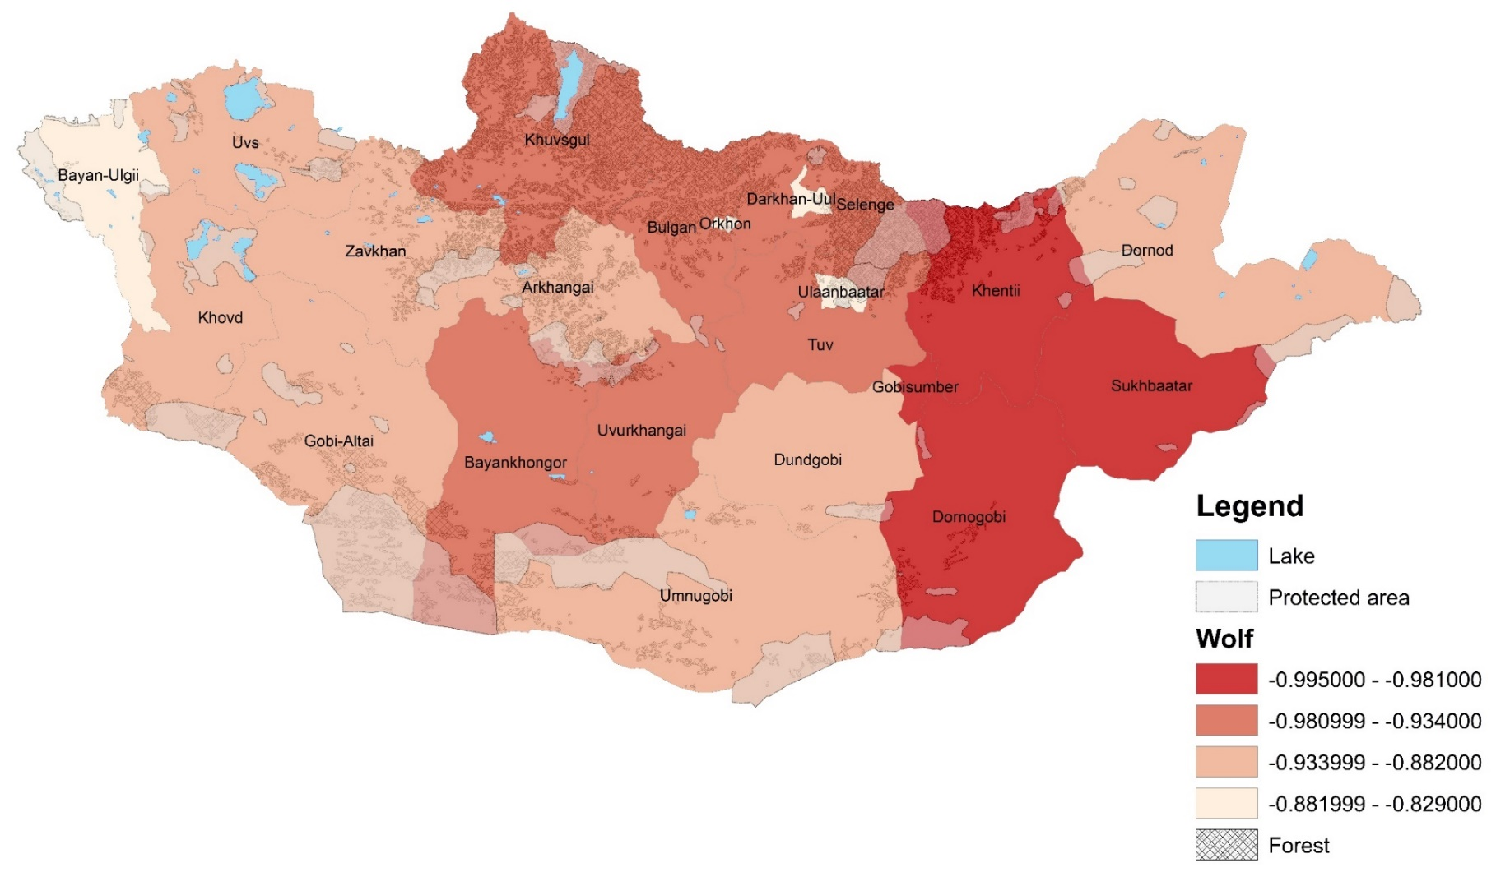**Figure 3.** The map shows significant changes in wildlife estimated numbers tendency correlated from livestock growth by each provinces. The correlation coefficient and red and green colour indicates significant negative or positive effects. Dark red colour indicates highest significant negative effect, green colour indicating significant positive effect and highest significant positive effect. The environmental layer such a forest and lakes for giving spatial imagination about provinces without species distribution.

**Figure 3.** (Continuation)

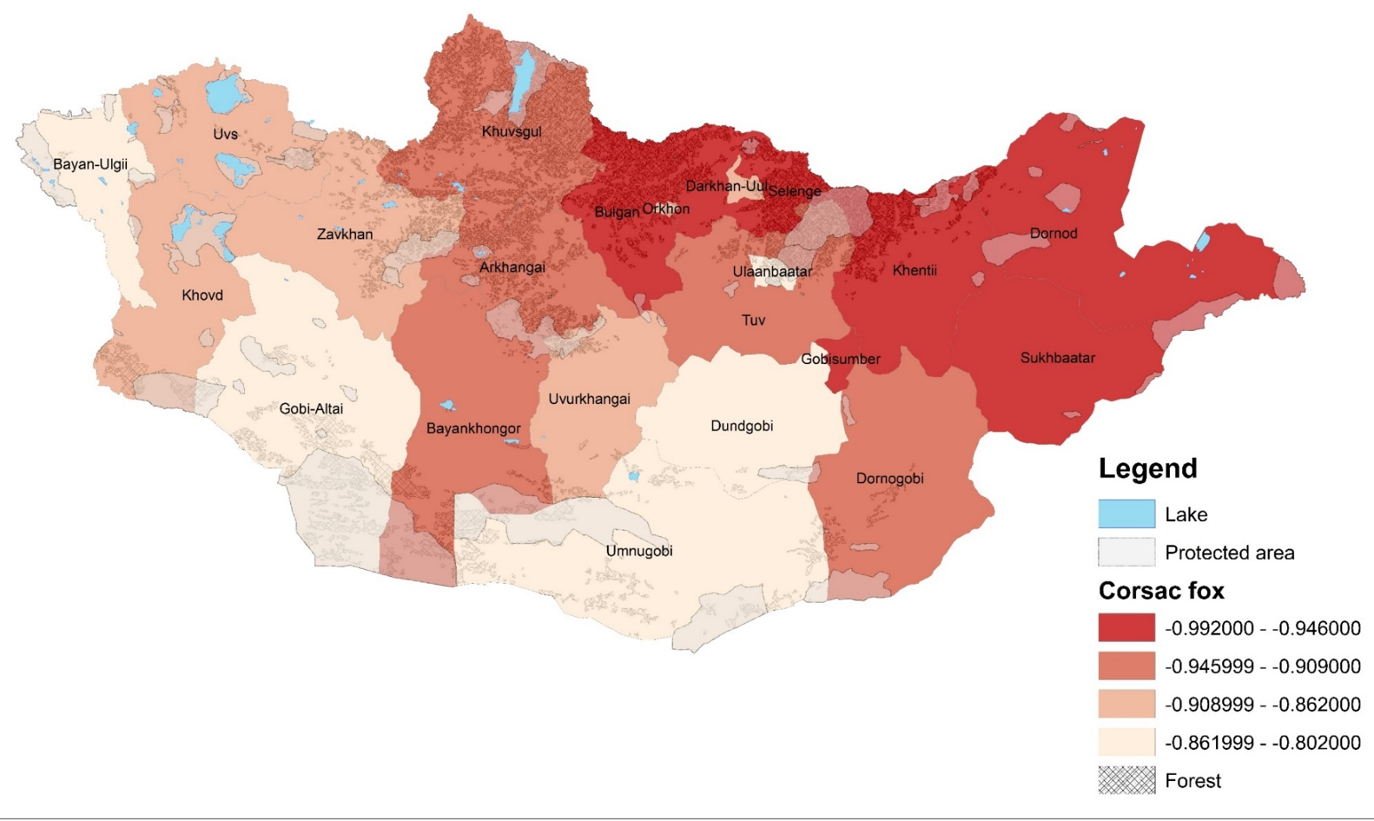

**Figure 3.** (Continuation)

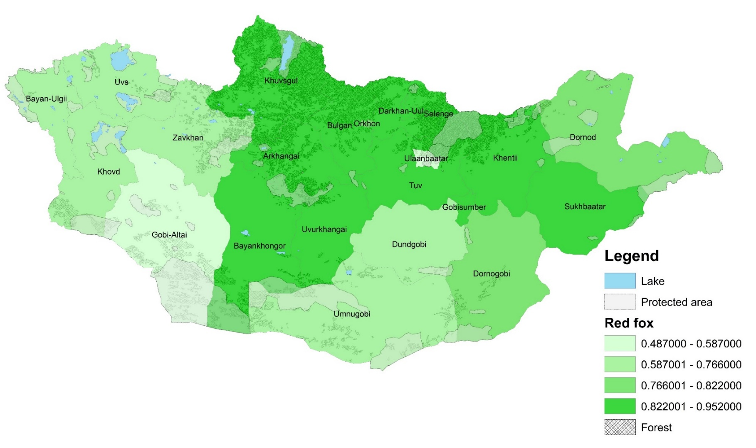

**Figure 3.** (Continuation)

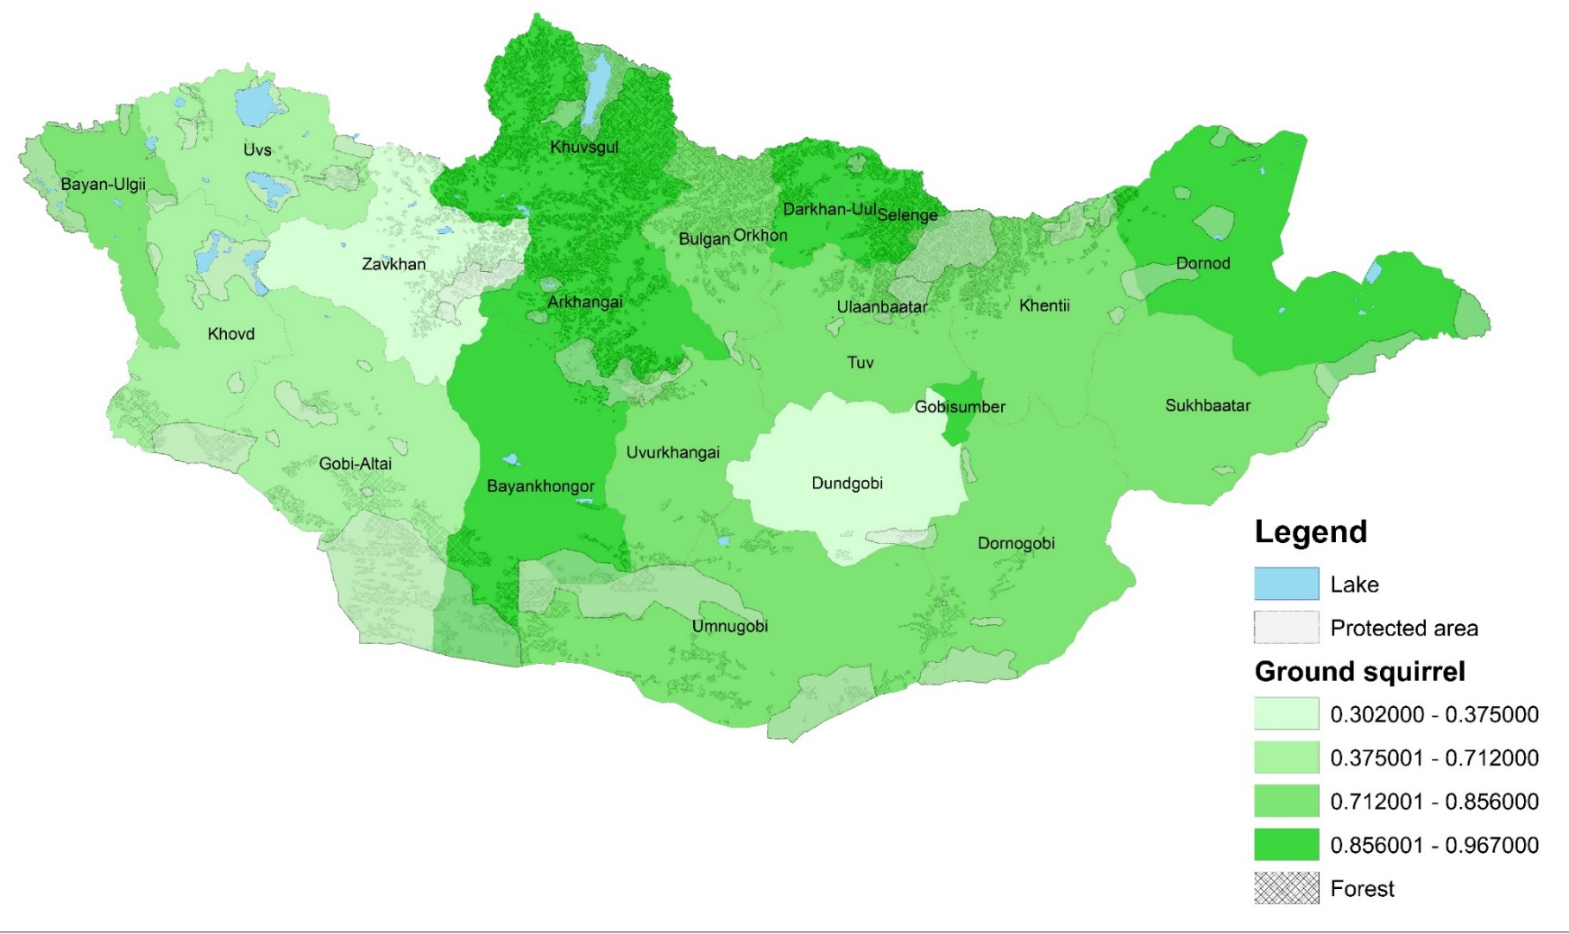

**Figure 3.** (Continuation)

